Solent University

Faculty of Business, Law and Digital Technologies

BSc (Hons) Computing
2022/2023
“The use of a Web based Paediatric Early Warning tool to support children with complex health needs in the community.”

Supervisor :
Date of submission : May 2023

Acknowledgements

Abstract
With experience gained from working in the NHS during my gap year, I possess a clear understanding of the limitations of technology in the healthcare system. Through my involvement in charity work with the CCN team in Cambridge, I had the opportunity to interact with children facing complex and life-limiting conditions. I witnessed first-hand how even minor changes in their physical health could have a profound impact. The CCNs were already utilizing a paper-based PEWS score to identify signs of deterioration in children's health, but it proved cumbersome and prone to inaccuracies during transcription.
To address these challenges, the following study explores research on ePEWS and develops a digital PEWS tool, offering time and cost savings for the CCN team and ultimately benefiting the NHS as a whole. A crucial aspect of the application's development was obtaining input from users, particularly the CCNs, to ensure their comfort and efficient use of the tool for recording PEWS scores. Surveys and interviews were conducted with CCN nurses throughout the study, providing valuable feedback and insights into their current PEWS practices and their thoughts on the proposed web application.
Incorporating common design practices alongside user preference resulted in a visually appealing and user-friendly application which recorded children's observations at home visits and reduced workload and admin for CCNs.

Table of Contents
List of Figures 6
List of Tables 8
1. Introduction 9
2. Literature Review 11
2.1 Digitalisation 11
2.2 Why PEWS? 12
2.3 Previous attempts to digitalised PEWS 14
2.4 Survey Analysis 15
2.5 Summary 17
3. Methodology 18
3.1 Pre-development: 19
3.1.1 Simulation 1: Single visit 19
3.1.2 Simulation 2: Multiple visit 20
3.2 Post-development: 21
3.3 Evaluation: 21
4.Project Management 23
4.1 Managing risk factors 24
4.2 Research 25
4.3 Designs 25
4.4 User testing 33
4.5 Redesign 40
4.6 Implementation 47
4.6.1 Introduction 47
4.6.2 Database 49
4.6.3 Functions 50
4.6.4 Sections of the application 57
4.7 Professional, Legal and Ethical issues 63
5. Results 64
6. Discussion 66
7. Conclusions 67
8. Recommendations 69
8.1 Finish implementation of all features 69
8.2 Extra security 69
8.3 Device compatibility 69
8.4 Making the PEWS parameters adjustable 70
8.5 Bluetooth and wearable technology 70
8.6 Linking it to SystmOne 70
8.7 WIFI and hardware limitations 71
9. Reference list 72
10. Appendices 77
Appendix A: Supporting artifact links 77
Appendix B: Survey questions 77
Appendix C: Survey Answers 78
Appendix D: Wireframes 79
Appendix E: Ethics form 83
Appendix F: Result Breakdown 85

List of Figures
Figure 1: Homepage design 27
Figure 2: Patient case load page design 28
Figure 3: Colour coded PEWS chart - Snelson, E. (2019) 29
Figure 4: Homepage dashboard design 30
Figure 5: PEWS chart page design 31
Figure 6: Input observation page design 32
Figure 7: Information pop up on observation page design 33
Figure 9: Analytics of user testing task 37
Figure 8: Heatmap generated showing navigation issues 37
Figure 10: Redesigned homepage dashboard 41
Figure 11: Epic EHR software with fake patient information displayed at the top of the page - Epic (2017) 42
Figure 12: SystmOne EHR software with fake patient information shown at the top of the page - Chapman, N (2017) 42
Figure 13: Patient information displayed at the top of the prototype page 42
Figure 14: Redesigned PEWS chart page 44
Figure 15: Redesigned patient case load page 45
Figure 16: Redesigned input observation page 46
Figure 17: SBAR page design 47
Figure 18: ERD diagram of the database 50
Figure 19: Code for LoginUser function 51
Figure 20: Code for SignupUser function 52
Figure 21: Code for addNewPatient function 53
Figure 22: Code for getAllPatientData function 54
Figure 23: Code for getPatientDataByID function 55
Figure 24: Code for calculatePEWS function 56
Figure 25: Code for getPEWSColor function 57
Figure 26: Implemented patient caseload page 58
Figure 27: Implemented homepage dashboard 59
Figure 28: Implemeted input observation page 60
Figure 29: Example of error handling in the observation form when an extreme value is inputted 60
Figure 30: Implemented patient registration form 61
Figure 31:Implemented PEWS chart page - Top 62
Figure 32: Implemented PEWS chart page - Bottom 63
Figure 33: Survery questions part 1 77
Figure 34: Survey questions part 2 78
Figure 35: Survey answers 78
Figure 36: Wireframe for the homepage 79
Figure 37: Wireframe for the login page 80
Figure 38: Wireframe for the patient caseload page 80
Figure 39: Wireframe for the homepage dashboard 81
Figure 40: Wireframe for the PEWS chart page 82
Figure 41: Ethics form 83
Figure 42: Ethics form 84
Figure 43: Ethics form 84
Figure 46: Nurse pay rate and Mileage pay rate 85
Figure 44: Time, mileage and cost breakdown for multiple nurse visits 85
Figure 45: Time, mileage and cost breakdown for a single nurse visit 85
Figure 47: Table showing the time taken by each nurse to take observations 85
Figure 48: Table showing the time taken by each nurse to input observations into both the current EHR and the ePEWS webapplication 86

List of Tables
Table 1: Simulation 1 - Single Visit 18
Table 2: Simulation 2 - Multiple visits 20
Table 3: Example results table 21
Table 4: Breakdown of the project management phases 22
Table 5: Competitive analysis of 3 NHS applications and EHR 25
Table 6: Breakdown of the user testing stages 34
Table 7: Time taken for observations to be inputted into the proposed eletronic PEWS application 36
Table 8: Time taken for observations to be inputted into SystmOne 36
Table 9: Key themes that came up in the interviews 38
Table 10: Table showing the priority of the features in the web application 46
Table 11: Results for a single visit for both not rush hour and rush hour 62
Table 12: Results for multiple visits for both not rush hour and rush hour 63

1. Introduction
Children’s community nurses (CCN’s) are recognised as an important part of the multidisciplinary team providing safe, effective high-quality care to children, young people, and their families. (The Royal College of Nursing, 2020) Despite their key role, it is an area of healthcare that is under-resourced and overworked. In 2015, the Royal College of Nursing recommended a ratio of 20 whole time equivalent CCNs for a child population of 50,000. (Fioretti, 2015) The NHS benchmarking document of 2020 states that there is only 3.7 CCNs per 100,000 child population. (Pruce, 2020a) highlighting the acute lack of workforce. The role of the CCN is paramount in keeping children with complex health needs at home and out of hospital, reducing anxiety for families, and saving money for the NHS. (QNI, Public Health England and DH, 2018) Their role is hampered by the lack of technology and digitisation in community healthcare. (The Queen’s Nursing Institute, 2018) Digitisation in healthcare, especially regarding workflow, allows nurses to do less admin and focus more on caring for patients, many of these systems are out of date or inefficient. (Davies, 2020) Inconsistency of approach has created fragmentation across the NHS resulting in a digital divide: some trusts have hardware and software allowing them to progress in using digitalisation, whereas the lack of this is a hindrance for others. (Agulnik et al., 2017a) Many trusts are risk averse and unwilling to invest in new initiatives unless they are nationally accredited or endorsed. The NHS IT Strategy recognised that lack of funding meant it was impossible to achieve the vision of a paperless NHS and instead went with small groups of digitally advanced providers with the thought to demonstrate what could be done. This approach increased the fragmentation, inequalities, resulting in differences in patient care. (Asthana, Jones and Sheaff, 2019) Currently, CCN teams use a mix of paper and electronic systems to log patient information. (Agulnik et al., 2017b) At present when taking observations, digital equipment is used to take the readings, these are written down on paper until the nurse gets back to the base, then input into the electronic medical record. This current practice incurs a clinical risk as information may get lost or transposed in some way whilst being transcribed as well as being time consuming and costly. (Shawahna et al., 2012). A study by Sefton et al (2017) identified a 14.5% error rate in paper-based documentation. It further identified a 98.5% accuracy rate when information is recorded directly into electronic records, as opposed to 85.6% accuracy with traditional paper recording. This shows a marked improvement in accuracy when using electronic recording. (Sefton et al., 2017) Errors in recording patient observations can have catastrophic results, with the deterioration in a child's condition being missed resulting in hospital admission or even death. (Agulnik et al., 2017c) Paediatric early warning systems (PEWS) were created to help recognise clinical deterioration in children. There is a nationally recognised system in use for adults called NEWS. However, this does not work for paediatrics, as age specific PEWS models are required due to the physiological variations in heart rate, respiratory rate and blood pressure from birth to adulthood. (The Royal Children’s Hospital Melbourne, 2019; Whzan Digital Health, 1998) Prior to the introduction of PEWS, there was no standard for escalation of care if a child seemed to be deteriorating, oftentimes it would be too late by the time a physician came to look at the child. When PEWS is used, teams can identify trends and predict if a child is deteriorating, allowing them to step in and change treatment sooner. (Atasoy, Greenwood and McCullough, 2019)
This project aims to produce a web-based tool that will digitalise PEWS recording, this will have many beneficial effects from reducing clinical risk through to saving paper, possibly most important for a public service it will reduce costs. The tool will support securing a consistent approach to care delivery with a portable digital record keeping system.
Clinical observations can be entered into a database by nurses, parents, or carers straight after conducting observations and collecting data. This information would then be plotted on an individual electronic PEWS chart. The chart can then be uploaded for the child's clinician to view and will help identify trends in the child's condition. The chart would show a visual representation of the child's observations as well as plotting trends over time spans, i.e. overnight, which allows for medical teams to look for deterioration as well as monitoring the child. Seeing these observations over an elongated period allows for carers to see where they could further support their patients.
There would be three important advantages for the digitalisation of the PEWS chart, all of which have significant cost benefits. It would provide more accurate results which would equate in a reduced number of A&E attendances, hospital admissions and fewer deaths. In addition, it would save time for the NHS as there would be a reduction in nurse mileage claims and nurses would spend less time doing admin. Finally, it would reduce if not eliminate data breaches and data inaccuracies due to human error.

2. Literature Review

2.1 Digitalisation
The potential for transformation in healthcare by use of widespread digital technology is huge, electronic health records make for easy access to patient information as well as increasing transparency and reducing error with improved legible documentation. There is the potential to reshape health care though changing the way patients engage with the NHS, including encouraging people to manage their own health and wellbeing. The number of self-care apps in use would indicate the appetite for this. The NHS continues to have a poor record in adopting digital technologies. Lack of investment as well as low user engagement has meant that change has not happened on the expected scale. Patients describe their experiences as “clunky and fragmented” and staff feel that poor IT experiences negatively impact their work, this highlights the importance of involving users in the design of technologies and understanding their needs. (Mistry, Maguire and Anandaciva, 2019a)

Although the NHS is a world leader in health care, its slow embrace of technology has long been recognised. (Liddell, Adshead and Burgess, 2008) The initial adoption of information technology (IT) is acknowledged as starting in the 1960s but it has only become widespread in the last decade. (Atasoy, Greenwood and McCullough, 2019)
The NHS 5 year Forward View produced in 2014 recognised that (NHS England, 2014) they were lagging behind comparable industries and countries. It also identified number of shortcomings including:
- No overall plan for adopting IT
- Different NHS services moving between highly centralised procurement and implementation, to thousands of individual local systems which failed to talk to each other.
The centralised approach failed due to lack of engagement and understanding of local circumstances and the individual systems meant that the benefits of an interoperable systems are lost. There are inherent risks in the fact that the IT systems in the NHS are outdated as highlighted in 2017 by the WannaCry Ransome worm, which was able to spread through the NHS due to lack of updating in Windows software. This resulted in many clinicians being unable to access computer records for days and thousands of consultations and operations being cancelled. (Fruhlinger, 2022)
In 2016 NHS England sought to champion the use of technology to improve practice and enhance outcomes for patients and staff. They especially realised the usefulness of technology in supporting communities in sparse areas, or for people who found it difficult to access medical settings. Such embracement of technology could also be beneficial to other areas of healthcare and social care. (NHS England, 2016)

The Digitalisation of care is integral to the long-term NHS plan. One key area is supporting people to self-monitor from their own home using digital tools. This is supported by organisations like the King’s fund who believe that care providers should be fully digitised by 2024. (Mistry, Maguire and Anandaciva, 2019b)
One example of a system that can be digitalised is PEWS, the digitalisation of which would enable children that have complex health to be monitored remotely. Medical staff would be able to review this information allowing decisions to be made without the need to travel miles for a face-to-face review, thus empowering families in making good health decisions.

2.2 Why PEWS?
Despite having the National Health Service, the UK has one of the highest mortality rates in children & young people from common infections when compared to countries such as Australia, Canada and Europe. (Ward, Wolfe and Viner, 2020)
In 2006, a pilot study into the reasons for child mortality found that 22% of deaths resulting from illness could have been avoided. The study recommended the implementation of an early identification system, namely an early warning score (EWS), to identify children at risk of developing critical illness. (Pearson, 2008)
In the adult world a standardised National Early Warning system (NEWs) was implemented in 2012 and has been credited with preventing over 1800 deaths a year. The success of NEWs highlighted the need for a similar system in paediatrics, however it was not just a case of using the existing tool as child physiology differs from adults and deterioration of their condition can happen much faster. Failure to respond in a timely manner to this deterioration, can lead to significant harm or even death. (NHS England, 2019)
Paediatric Early Warning Scores (PEWScores) describe tools that collate vital signs along with measurable characteristics resulting in a threshold for response. These range from a numerical score made up of individual components or a trigger resulting from any one component which exceeds predefined thresholds. (Roland et al., 2021)
Leicester Royal Infirmary initiated the POPS (Paediatric Observation Priority Score), consisting of 8 domains, each graded 0, 1 or 2 to give a total score of 16 .
- Oxygen saturations
- Level of alertness
- Extent of breathing difficulty
- Background history
- Nurse gut feeling
- Heart rate
- Respiratory rate
- Temperature
Physiological sub-scores carry a total of ten points, with gut instinct and appearance sub-scores (level of alertness and extent of breathing difficulty) contributing a further six potential points. Adding gut instinct allows for the experience of staff or parents who often know the child well and can identify issues before the physiology scores change. The tool not only allowed for identification of a deteriorating child but also highlighting those who could be managed safely in the community. It was recognised that a PEWS tool can reduce referrals of all children with potential concerns to an acute setting, reducing pressure on overstretched systems and avoiding unnecessary admission to hospital. (Roland et al., 2016)

Henderson (2012) wrote about initiating PEWS in a rural area of Scotland. PEWS enabled practitioners in rural and community settings to be proactive in managing the assessment and monitoring of children, interpreting any deterioration quickly and summoning appropriate support. Once the PEWS score was calculated they initiated a process dictating 4 possible actions to be taken:
- Inform nurse in charge
- Increase frequency of observation
- Call for medical review
- Present child to medical team
This ensured that even inexperienced staff were able to follow a course of action once a PEWS trigger has been identified.

The Facing the future together for child health’ document in 2015 recognised that more than a quarter of A&E attendances are children. Often the child's illness will be minor, requiring little or no medical intervention, making these attendances inappropriate or unnecessary. What these attendances highlight is the concern or anxiety of parents who are unaware of how to access more appropriate services. As well as being unnecessary, hospital attendance is costly, not only to the NHS but to families regarding travel time & cost, school absence and separation from family members. Many episodes even of acute illness could be better managed in the community with support of appropriate tools and communication. The report highlighted that no child should be in hospital when care of an equivalent or better standard could be offered at home. CCNs are perfectly set to be able to support parents and children at home, providing an acceptable alternative to hospital settings and reducing parental anxiety. Introduction of a PEWS tool can enable parents of children with long term conditions to alert CCNs when the child's condition changes. The CCN can then assess whether the child requires admission to hospital, avoiding unnecessary hospital attendance. For children that do require hospital admission, PEWS can enable CCNS to facilitate early discharge, reducing time in hospital but providing continuation of the care in the home. (Royal College of Paediatrics and Child Health, et al, 2015a)

2.3 Previous attempts to digitalised PEWS
In 2015 ‘The Facing the Future for Children's Health’ document stated that information regarding children should be readily available to those looking after them. It highlighted that information should be recorded at point of contact with a professional and should be accessible in a safe and secure manner across all systems involved with the child. (Royal College of Paediatrics and Child Health, et al, 2015b)
Tomasi et al. (2020) recognised that Bedside PEWS improves ability to detect deterioration in children's conditions, their article highlighted that Electronic PEWS resulted in 15.7% fewer calculation errors than paper recorded PEWS. Electronic PEWS has a number of usability benefits including more accurate data plotting, automatic score calculation and the ability to eliminate double recording. These improvements result in reduced errors, reduction in nursing time leading to cost improvements, ultimately improving and standardising care in community settings.
Sefton et al. (2017) highlighted that process errors in recording data, including plotting on paper charts and calculation errors can have a negative impact on PEWS scores. In comparison between electronic and manual recording there was an improved accuracy of 98.5% v 85.6% using an electronic recording tool. The warning score calculation was improved 94.6%v 55.7% and time saving of 68 seconds v 98 seconds in paper-based documents. Over time this would equate to a cost and time saving for an overstretched NHS. Paper based documentation has the potential to impede delivery of safe clinical care due to inaccurate, illegible or incomplete documentation. The progression towards electronic recording and documentation of vital signs will result in improved clinical care. The article found that on paper recording, even where all data points were recorded correctly the PEWS calculation could still be found to be incorrect. This error rate was almost eradicated using an electronic system of recording. Calculation errors, errors of omission and transcribing errors were eliminated.

A study for the BMJ in 2021 found that at least 25% of organisations in England had introduced an electronic PEWS tool and within a year it was estimated that ePEWS would be in over half the organisations caring for children. This highlights the necessity of developing an electronic system to work alongside any existing paper system being used. At present it is recognised that there is a lack of a single nationally validated PEWS, presenting a patient safety risk especially where staff may move across different settings. A standardised electronic system could eliminate variation and reduce likelihood of errors. (Roland et al., 2021c)

PEWS is recorded from observations taken by a nurse at the patient bedside and the calculated score then entered into medical records. The method is beset with problems such as transcription of information, delayed or inconsistent nursing documentation which seems to undermine the real time identification of children at risk of clinical decline. Automated PEWS were found to be more accurate than manual calculation. Manual calculation in PEWS can be prone to human error, either in entering information or calculating a score, automated calculation by electronic tools can prevent this.
(Lockwood et al., 2020)

2.4 Survey Analysis
Although a fair amount of information around PEWS was obtained by looking through published literature, it was difficult to find information that focused on community nurses' experiences with PEWS and how they use it. As there is a CCN team in the local area the decision was made to contact them. Initial contact was made with the service lead to ask permission to send a survey to the members of the CCN team and to be able to interview them.
A survey was sent out to the CCN nurses to obtain background information of their current use of PEWS. From this it was possible to establish if the nurses are actually using PEWS in practice, their views and concerns around current practice and ideas for improvement. It is recognised that Nurses are extremely busy and so the survey was deliberately short in order to avoid impacting too much on their clinical time. The survey was created using “Jisc online surveys” in line with Solent university policy. Participants were asked their thoughts behind PEWS, the good and bad aspects of it, if they think it can be improved and if digitising the tool would help improve compliance and recording. The survey questions can be found under appendix B.
Hennink and Kaiser (2021) state that when getting qualitative data and dealing with a homogenous population which in this case are CCNs with similar backgrounds and current career paths, an adequate survey sample size is reached with 9-17 participants. In this case 15 CCNs responded to the survey. An email was sent alongside the survey link, explaining the aims of the survey that they were participating in, the process and what the outcome would be.
When analysing the survey answers, 93% of the nurses in the CCN team use PEWS when visiting children in the community. This supports that PEWS is actively being used in patient observations and therefore will need to be included in any attempt to digitalise this aspect of social care. (View all answers in appendix C)
The majority of responses were consistent in their views regarding the good aspects of PEWS, commenting that it helps give an early indication if a child's health is deteriorating, also helping to open up an universal conversation with other health professionals. The bad aspects were more varied, one issue was that the nurses said they do not always have a PEWS chart in the child’s home and they may not have paper to note down the observations or PEWS score. This means the nurses have to try to remember the observations in order to record them when they get back to base. There is a high chance that information can be forgotten in this situation, making the process redundant. Other nurses commented on how the process was made onerous by having to take the observations at the house, record them on paper and then having to input them on the electronic record back at base. A large negative noted by a number of CCNs was that parameters cannot be altered for individual patients who due to their medical condition have observations outside “normal” parameters. This can result in PEWS being falsely triggered which inexperienced staff may not realise, resulting in additional hospital attendance, totally the opposite to what PEWS is supposed to achieve.
All the CCNs who undertook the survey expressed an overwhelming positive response to the idea of a digital PEWS tool allowing input of observations at the point they were undertaken with the child. Comments included “it would reduce errors and save time and money” both of which are important for such a critical service.

2.5 Summary
The implementation of electronic Pediatric Early Warning Score (PEWS) tools in the CCN team can lead to significant improvements in the accuracy of data recording, reduced errors, and standardised care. Research studies have consistently highlighted the benefits of electronic PEWS over paper-based systems, including reduced calculation errors, automatic score calculation, and elimination of double recording. The transition towards electronic recording and documentation of vital signs will result in improved clinical care, reduced cost, and time-saving for an overstretched NHS. While there is still a lack of a single nationally validated PEWS, it is encouraging to note that at least 25% of organisations in England have already introduced electronic PEWS, and within a year, it is estimated that ePEWS would be implemented in over half of the organisations caring for children. Survey results from 15 CCNs showed that 93% of them use PEWS when visiting children in the community. However, the nurses also highlighted the challenges of not always having access to PEWS charts in the child’s home and not having paper to note down observations, which leads to a high chance of forgetting information. Therefore, there is a need to develop electronic systems that work alongside any existing paper system being used in community settings.

3. Methodology
The project was broken into two distinct parts:
- Pre-development – before the application and prototype were developed.
- Post-development – after the application and prototype has been developed
This provided quantitative data allowing a comparison to demonstrate if the prototype improved the process of carrying out PEWS observations. A time and cost stimulation was created to obtain this quantitative data. This stimulation involved assessing how long it took a CCN to input the observations into a child’s records. The planned testing highlighted benefit both financial and in time management for the Trust.

3.1 Pre-development:
This process involved a number of steps for two simulations (individual patient and multiple visits):

3.1.1 Simulation 1: Single visit

Step one | Inform user(CCN) of purpose of the test and how it is was to be carried out
Step two | Google maps was used to calculate mileage and time from the CCN’s base to a set address in Cambridgeshire
Step three | CCN recorded my observations as if I was a patient. This consists of respiratory rate, heart rate, blood pressure, oxygen saturation, temperature, level of consciousness and capillary refill time.
Step four | CCN recorded observations on paper as they would when conducting a visit with a patient.
Step five | Google maps used to calculate time and distance back to the base
Step six | CCNs timed inputting information into a computer spreadsheet.  In order to simulate real time work experience the user had to wait for the computer to turn on, login to the computer and finally input the child’s details into a spreadsheet.
Table 1: Simulation 1 - Single Visit

3.1.2 Simulation 2: Multiple visit

Step one | Inform user (CCN) of purpose of the test and how it is was to be carried out
Step two | Google maps was used to calculate mileage and time from the CCN’s base to a set address in Cambridgeshire
Step three | CCN recorded my observations as if I was a patient. This consists of respiratory rate, heart rate, blood pressure, oxygen saturation, temperature, level of consciousness and capillary refill time.
Step four | CCN recorded observations on paper as they would when conducting a visit with a patient.
Step five | Google maps was then used to calculate time and distance to the next patient’s house in another village around Cambridgeshire such as Trumpington.
Step six | Steps four to six were repeated three more times. Each time the mileage, time and observations were recorded.
Step seven | Google maps was used to calculate time and distance back to the base.
Step eight | CCNs were then timed inputting the information from multiple visits into a computer spreadsheet.  In order to simulate real time work experience the user had to wait for the computer to turn on, login to the computer and finally input the child’s details into a spreadsheet.
Table 2: Simulation 2 - Multiple visits
The values from the two simulations were gathered and written down in a table allowing us to view them and compare the results.

3.2 Post-development:
For post-development the simulations were repeated but rather than the CCN returning to base to input data, they did it at the patient's visit on a tablet. In simulation 1 (single visit) steps 1- 3 remained the same, with the difference being in the last step where CCNs were timed entering observations on to the app while with the patient.
Simulation 2 (Multiple visits) had similar steps to the pre-production simulation. Steps 1- 3 remained the same but after taking the patients observations the values were again entered directly to the web application during the home visit. Time and distance to the next visit was recorded and the process repeated with the next patient.

3.3 Evaluation:
Values from both simulations were input in tables, with a separate table for each simulation. Once all the data was gathered from the participants a table collating all the averages was produced highlighted whether there is an improvement in using the application. Costs were worked out to see if a reduction in time and mileage resulted in significant savings. The costs were calculated on and mid Band 6 nurses pay at £19.88 per hour. The Trust also pay £0.59 per mile, using these figures it was possible to work out average costs per visit.

Overall values | Pre-development | Post-development | Difference
Time
Mileage
Cost
Table 3: Example results table
If the overall difference values are negative, it will show the prototype was successful in making efficiencies and cost savings. If values stay at 0 then the application made no difference a positive value would indicate the app has in fact made things worse.

4.Project Management
The project will consist of 6 main phases:
Phase | Stage | Compolents | Status
1 | Research | Literature review | Completed
 |  | Survey | Completed
2 | Designs | Competitive analysis | Completed
 |  | Low fidelity wireframes | Completed
 |  | High fidelity prototype | Completed
3 | User testing | Interviews | Completed
 |  | User testing | Completed
4 | Redesigns | Redesigning the high fidelity prototype | Completed
5 | Implementation | Coding the application | Completed
6 | Evaluation | Going through the methodology | Completed
Table 4: Breakdown of the project management phases

4.1 Managing risk factors
An Agile methodology was adopted for this project as its flexible approach allowed for collaboration with stakeholders. In this case, the stakeholders were the CCN team and due to this being a serious issue dealing with the health of children, the web application needed to be easy to use and efficient. The PEWS tool required flexibility in design as the stakeholders found what worked best with individual children, making it a process rather than the tight linear sequential phases of the waterfall methodology. The iterative approach meant that even if the project overran or was not finished, there was still something to present at the end; it just may have had fewer features. This resulted in less risk as there was an end result, which was another reason why it was chosen over a more linear approach like waterfall.
From the interviews and requirement gathering stages, key features will be found / selected. These features will be prioritised in terms of importance and organised into a sprint system. This is beneficial in terms of this project as we have limited time so it means that potential changes can be identified quickly and keep the project moving. (XDesign, 2021)
Each sprint cycle will be composed of elements split into a flow diagram. In order to check the code, a set task feature such as login or inputting new observations would be done. If this is successful, then the next sprint would commence (implementing a new feature) and the process would start again.
Through the duration of the project there were a number of limiting factors which occurred which had to be managed:
- The most ideal way to have undertaken research for the project would have been to follow a number of CCNs through their working day carrying out a time in motion study as this would have highlighted more possible issues involved in carrying out a PEWS assessment. This was not possible due to confidentiality and ethical issues around having research carried out with children. To mitigate this, the CCNs carried out PEWS assessments on me and then entered information on to a spreadsheet.
- One of the key areas of pre and post development were the survey and interviews with the CCN team. There were some issues with this process as for the first time the nurses in the RCN union had decided to take strike action as a result of the increasing pressures that the NHS is under, including CCN teams as highlighted in the introduction. This meant that there were a number of days where the CCN service was working on very reduced capacity and so had to concentrate on core work meaning that nurses were not free to complete surveys or conduct interviews. The local CCN team has also recently gone through a large period of change resulting in 40% of staff leaving. Changing the interview process to Teams interviews rather than face to face was a way to mitigate this and make it easier for the CCNs as it did not take so much time out of their day.

4.2 Research
Google Scholar was used to search literature for this project, with the aim of gaining more background information into PEWS and digitalisation in the NHS. It is a widely-used search engine that enables scholars and researchers to access a vast array of academic literature. Relevant keywords or phrases related to PEWS, early warning systems in healthcare and digitalisation in the NHS were put into the search bar. The search results were then refined using various filters such as publication date and location as the focus was to be on UK research. The identified articles were then read and key points highlighted. This helped determine whether the article/journal was suitable.
Surveys were also carried out to help obtain further research, using the CCNs who are currently using PEWS in practice. The surveys were generic and sent to all members of the nursing team. The decision to use surveys enabled contact with a large number of CCNs and allowed them to answer at their convenience. This contrasted with the interviews that were conducted with just a small number of identified CCNs due to pressure on workload. The qualitative data received from the CCNs added to the research in regard to present views and practices in relation to PEWS and identified key areas such as cost savings.

4.3 Designs
Figma was selected as the design platform for the project, prior experience with this platform meant that it was easy to navigate, allowing for a quick and simple design phase as no extra software learning was required. (link to prototype in appendix A)
Research into other NHS applications gave examples of existing designs and systems that are currently used. A competitive analysis was done on three NHS approved applications to highlight key themes and issues.
Application | Purpose | Useability | Comments
NHS app | For patients:  Allows users to access health records, view appointments, order prescriptions, view messages from their GP surgery. | - There is no separation between the nav bar elements meaning it is hard to identify the individual buttons.  - Grey and blue main colours  - Very TCD approach  - Buttons are not clearly defined and look just like dropdown boxes or information boxes (home button included)  - Nav bar is easy to see at the bottom of the page if not a little small. | - uninteresting and mundane design  - unimaginative  - overcrowding on pages
Epic | For doctors, nurses, and admin:  electronic patient record system | - Extremely overcrowded  - No set colour guide or consistency between buttons  - No set art style between icons  - No consistency on rounded edges on buttons/pages  - Extremely poor visibility  - Bad mapping  - Very TCD approach | - Uninteresting and mundane design  - Unimaginative  - Extreme overcrowding on pages  - Overall, very bad user experience  - Clear patient information at the top of the display
My chart | For patients:  Allows users to access health records, view appointments, input current health problems and conditions, View test results | - blue main colour  - bad feedback  - dashboard Homepage | - unsophisticated design  - uninteresting and mundane design
Table 5: Competitive analysis of 3 NHS applications and EHR
The analysis highlighted that NHS digital applications are generally extremely hard to navigate, difficult to use and boring, so the first issue that needed to be addressed were these aspects.
(Mistry, Maguire and Anandaciva, 2019c)

Wireframes were developed with a basic dashboard layout for a standard desktop (1440 x 1024 - suggested by Figma). (To view wireframes, view appendix D) Dashboards are good for displaying large and clear amounts of visual information which is useful when dealing with PEWS as it means nurses/clinicians can clearly see if the patient is deteriorating without having to waste time going through their notes. (Janes, Sillitti and Succi, 2013)

Due to the time constraints the wireframes were not tested but instead a high-fidelity prototype was made for testing, based off of these wireframes.
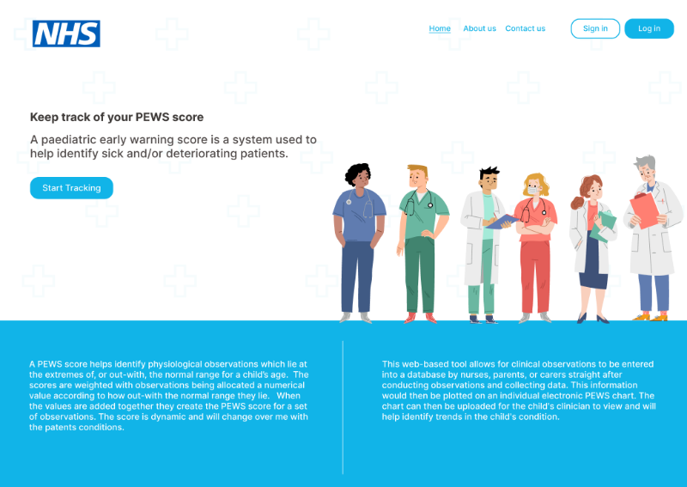
Figure 1: Homepage design
As the application is going to be used with children, it was important to make the application colourful and playful to help combat the overwhelming corporate feel that the other NHS applications have. Simple images of doctors and health care workers were added to help bring some colour to the application without having it be overwhelming and ostentatious. To follow this playful theme the buttons and information boxes all have curved edges resulting in a softer feel. The Barrow Neurological Institute (2008) has conducted research that suggests that rounded corners are easier to view for users as they appear less bright. This design element contributes to the calming aspect of the application. (Troncoso, Macknik and Martinez-Conde, 2008)

Similarly, to other NHS applications, blue was an overarching colour used throughout the application. The use of colour plays a fundamental role on human mental processes, as demonstrated by Bartram, Patra and Stone (2017) research team. Through their results of a Kruskal-Wallis test, they found that alterations in colour can influence an individual's psychological state. The test concluded that the colour blue is associated with feelings of trustworthiness and that desaturated colours tend to evoke an overall sense of relaxation and calmness. These seemed like valuable feelings to promote in a healthcare application.

This consistency of colour palette and rounded edges of this application help contribute to the overall aesthetic of the website. It is stated by Kurosu and Kashimura (1995) that the more aesthetically pleasing an application the more tolerant users are to usability issues they may come across.
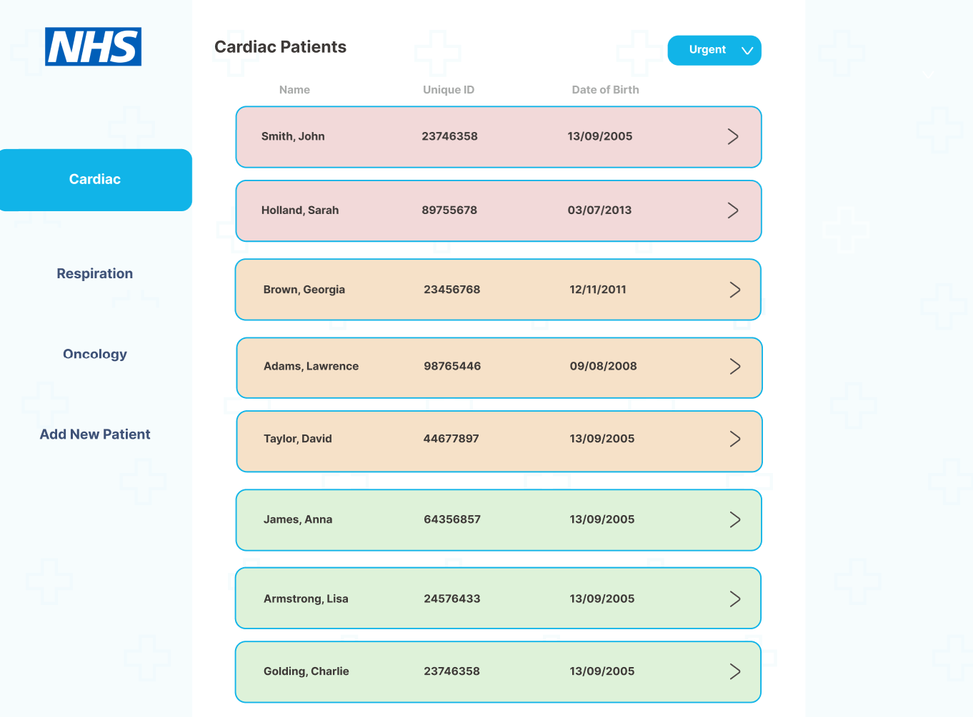
Figure 2: Patient case load page design
When logging on to the application CCNs are faced with a screen showing a list of caseloads by condition (cardiac, oncology etc) at the side and then children’s names. This reflects the way that the nurses currently view their patient caseloads, making it seem familiar and easy to access. The buttons leading to the patients files are colour coded green, amber and red depending on their PEWS score. This links to the traffic light colouring used on traditional paper PEWS tools.
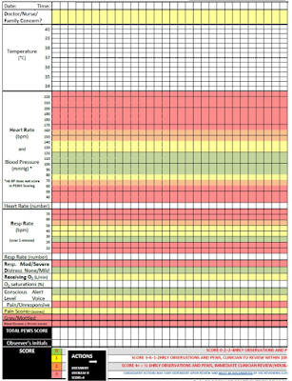

Figure 3: Colour coded PEWS chart - Snelson, E. (2019)
©GPPaedstips

This colour coded system allows the CCN’s to clearly see which children are scoring high on the PEWS on average over a week meaning they may want to visit and assess these patients sooner. It also assists in weekly allocation of visits and workload.
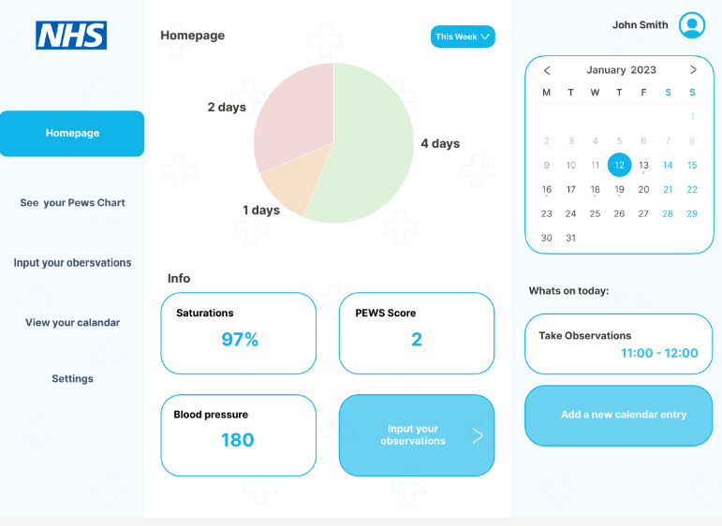
Figure 4: Homepage dashboard design
The dashboard was split into three main sections: the nav bar, results section and calendar. These sections were achieved by consulting the Gestalt principles and taking into account common regions. The light blue backgrounds help give a perceived separation between the objects on the page. (Sternberg, 2011)
In the centre of the homepage is a pie chart showing the days on which the average PEWS score was high. This is a nice and clear way to show the data at a quick glance which would be helpful to busy CCNs in the community.
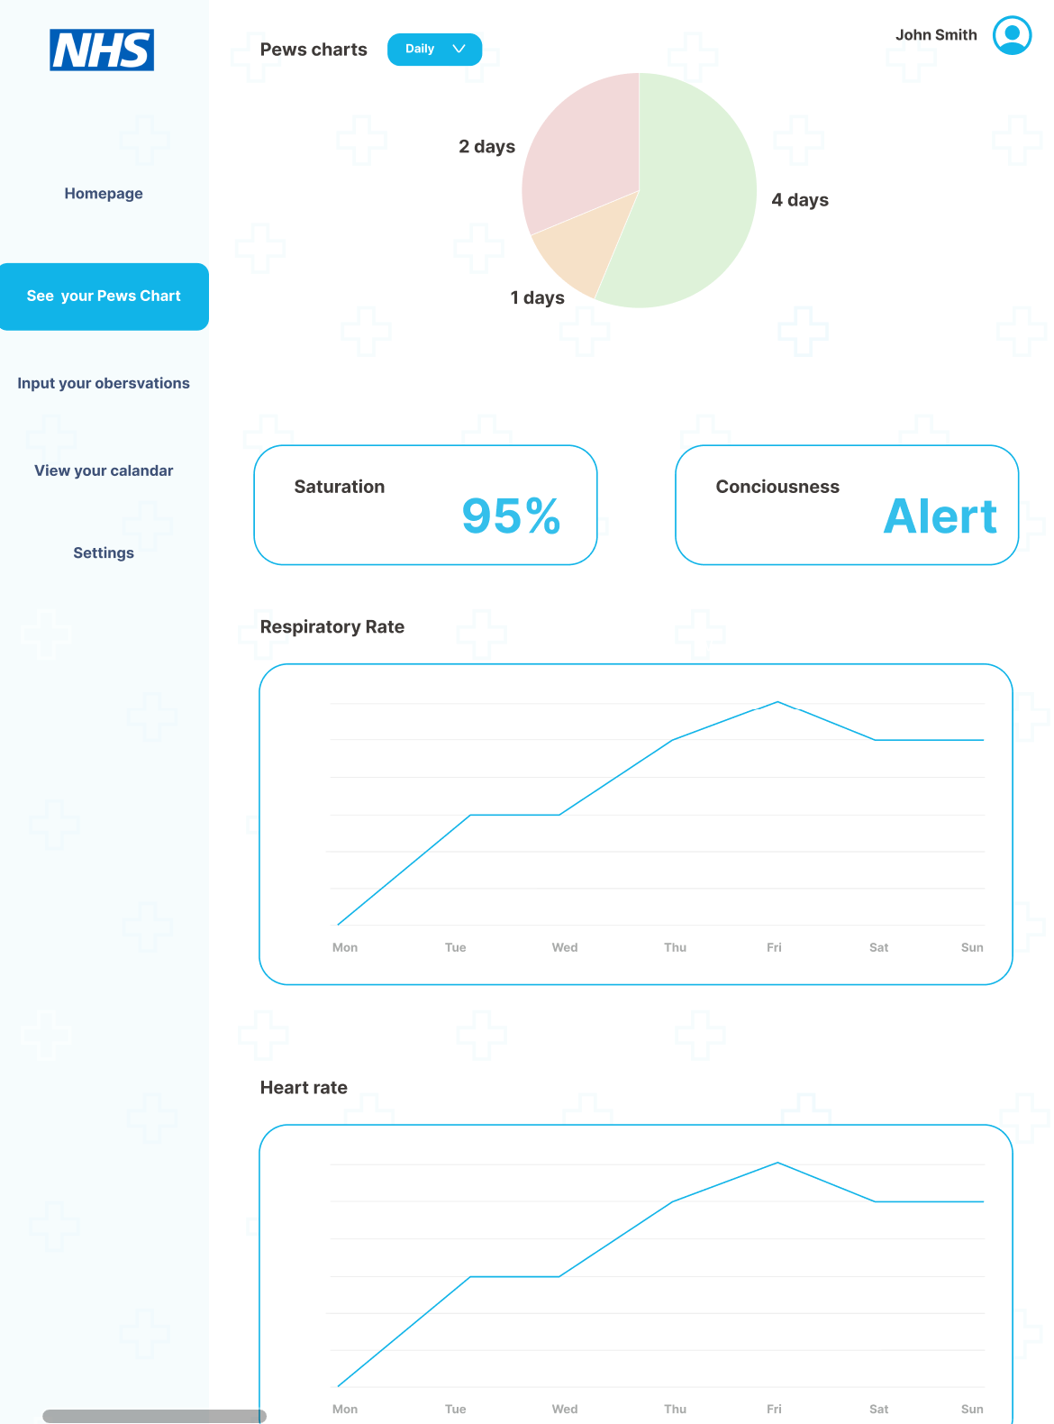
Figure 5: PEWS chart page design

The PEWS charts are represented as a line graph just like they are on the paper PEWS chart. This presents a level of consistency between the charts, meaning that health professionals should recognise the format and be able to easily make the change to using the new tool.
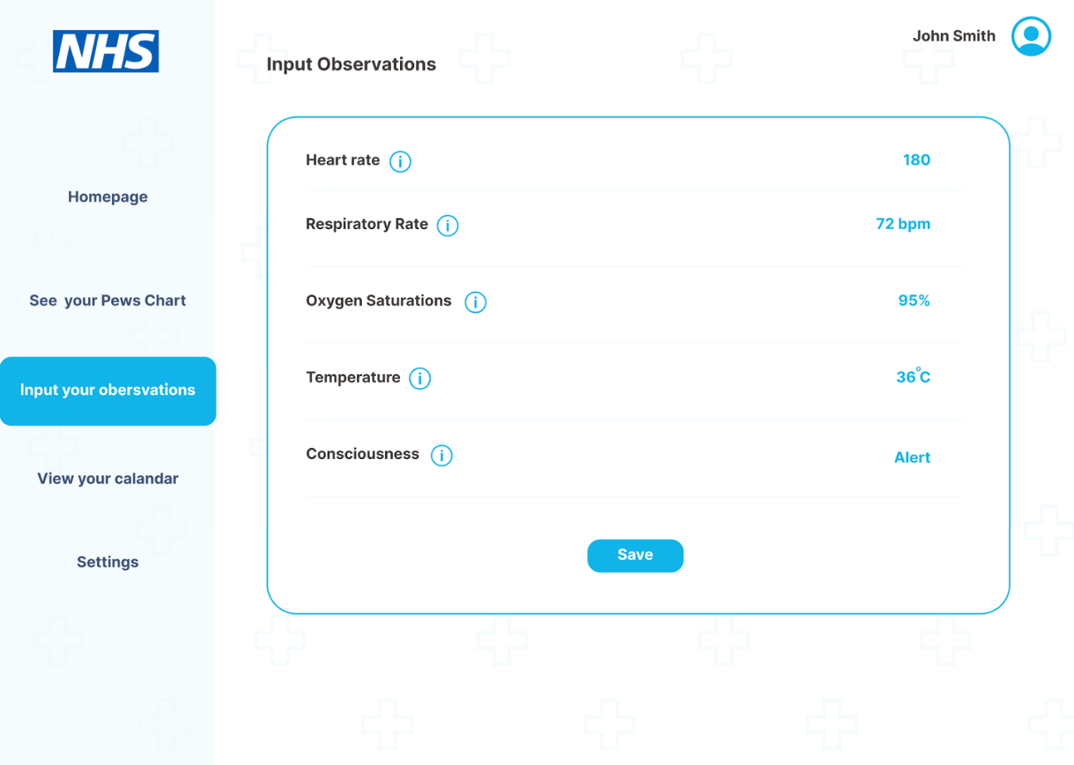
Figure 6: Input observation page design

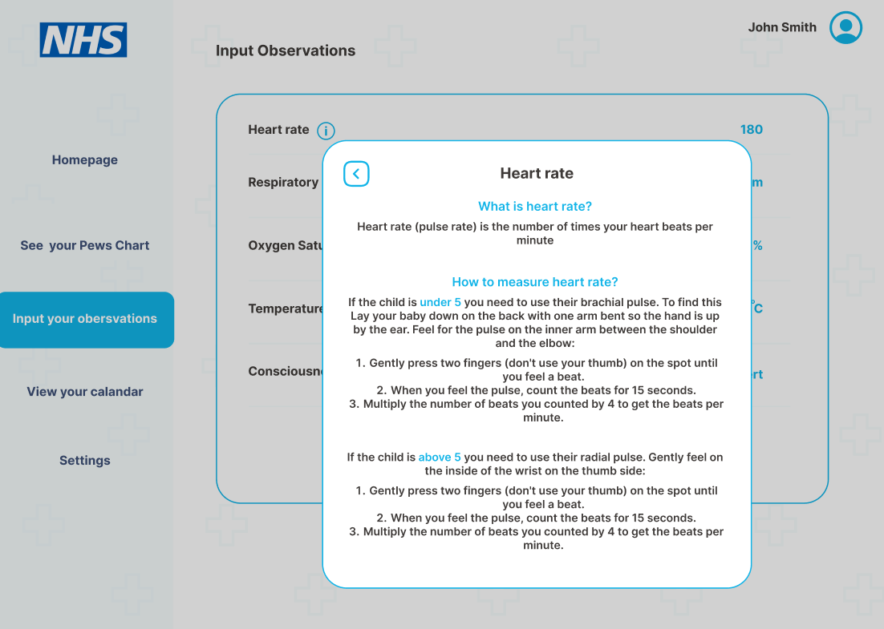
Figure 7: Information pop up on observation page design

On the observation page, instruction buttons were added next to each label. This contains a clear explanation into how the relevant clinical observation should be obtained and measured.
As this application is designed for both Nurses and carers/parents this seemed like an important aspect to add, it would help to improve accuracy of parents and carers or inexperienced staff, taking the observations of children. It will help give parents/carers confidence and mean that they are less likely to make repeat calls to CCNs asking these basic questions.

4.4 User testing
To ensure the PEWS tool was effective and efficient it was important to identify a user group who could provide good insight into this. Purposive sampling of the CCN team was chosen as they would meet specific criteria required for the project ensuring that requirement gathering would meet the project's aims (Palys and Given, 2008). Identifying a team who fulfil a particular role means that you can select individuals and focus on a relatively small sample. (Nikolopoulou, 2022) In this case our purposive sampling was made up of face-to-face interviews with 5 of the CCN team. Certain criteria were set for the CCNs who were interviewed. (Jordan, 2021) (To find transcripts of interviews please see appendix G)
These were:
- Nurse should have 2 or more years’ experience as a CCN
- Be involved in caseload managing children with complex health conditions.
The user testing process will consist of 4 stages:
Stages | Type | Data you get | Key Information | Artifacts needed
1 | Ask questions about PEWS | Qualitative data:  - Similar questions to the survey  - Features CCN’s would like to have in a PEWS application how it would benefit them. (eg A traffic light system highlighting the more sick children) | In order to reduce possible interviewer bias and judgement, structured interviews were conducted, ensuring all interviewees were asked the same questions. (Kutcher and Bragger, 2004) These questions were the same as the survey.  Individual interviews give opportunity to gain individual information reducing chances of things being missed in a group setting due to too much going on. (Downey, 2007). | - Set of Interview question  - Consent forms for all the nurses  Permission from the service lead
2 | Have the user use the prototype | Quantitative data:  - Have the user carry out a task such as inputting observations into a patient's file.  - Allow the user to explore and navigate around the application.  - Time the user doing the task establishing an average on how long it would take the user to input values into the application. | To conduct these user tests a website called useberry will be used. (Link to survey in appendix A)  As the PEWS tool is a new application the time taken to enter the information must be taken into consideration as the new layout could take some time for the CCNs to navigate, against the electronic records they are already familiar with. | - High fidelity clickable prototype  - Usability tests set up with key tasks for the user to complete.  Heat maps and timed results were generated for analysis.
3 | Ask questions surrounding the prototype | Qualitative data:  - To obtain CCN’s thoughts on the prototype  - To see if they think any features are missing.  - Understand there assessment of useability of the app and if would be useful in practice | Much like the previous questions a scripted interview was conducted. | Set of question surrounding prototype
4 | Record time taken for nurses doing admin tasks | Quantitative data:  - Recording time:  - Log into system one (the NHS medical system),  - Search and select the patient.  - Input recorded observations | Recording the time taken to conduct this task will give us a basic average on how long nurses are spending doing admin tasks. This assists with the methodology as it will allow our results to be more accurate. | - Permission from the service lead  Stopwatch
Table 6: Breakdown of the user testing stages
One aspect of user testing was to establish how easy the app is to navigate, by seeing how easily a user could complete a simple task and record time taken. Heatmaps were generated to help gain insight into how the users used different elements on the page and see if they found them useful or not. In the example below, when asked to input observations, the CCNs were able to easily identify the clear buttons and Nav bar. It took users an average of 19.1 seconds to complete this task from the login page. The heatmap also indicates that more users look and use buttons in the main homepage over using the nav bar. This helps enforce the idea that having the buttons clearly represented in the main page of the application is a good idea rather than relying on the navigation bar.
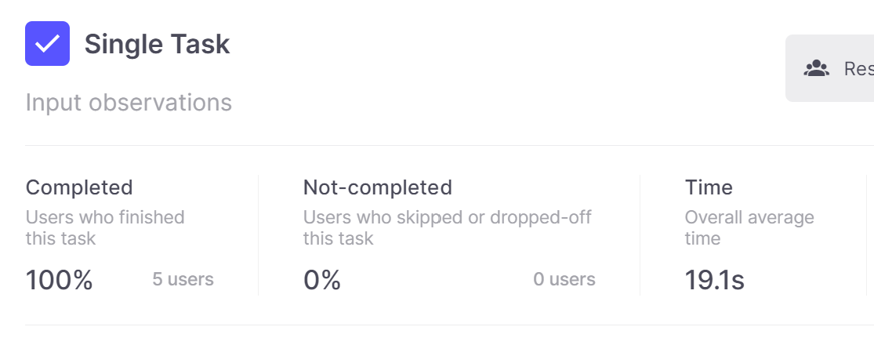
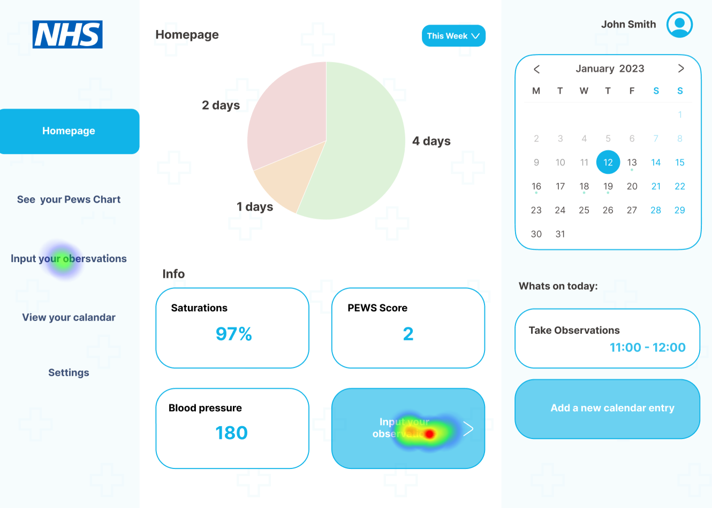
Figure 9: Analytics of user testing task
Figure 8: Heatmap generated showing navigation issues
The CCNs were asked to perform a similar task with their present system, requiring them to navigate a patient's medical file and input the observations they had recorded in the home.
Table 7: Time taken for observations to be inputted into the proposed eletronic PEWS application
Inputting observations into the proposed prototype application
Users | Time taken to input observations
1 | 19.3 s
2 | 23.7 s
3 | 11.4 s
4 | 24.4 s
5 | 16.5 s
Average | 19.1 s

In order to keep a controlled experiment, the CCN’s were timed from the login page on SystmOne (the current electronic health record system)

Inputting observations into the current application
Users | Time taken to input observations
1 | 72.4 s
2 | 79.2 s
3 | 74.8 s
4 | 81.2 s
5 | 76.3 s
Average | 76.8 s
Table 8: Time taken for observations to be inputted into SystmOne
As shown by the results, the new application resulted in a 75% decrease in input time, compared to the current system. Although these designs were not final it was reassuring to see this decrease in time indicating that this application would in fact reduce time taken for the CCNs to input results into patients notes.
Transcripts were taken of each user test and then the result will be analysed. Analysing the transcript will just bring light to the qualitative (and some quantitative) data we obtained. Thematic analysis was carried out to analyse the transcript as it was deemed most useful when dealing with large amounts of qualitative data. Useful patterns and themes were found across the data such as:
Themes | Key points
About PEWS | - Universal way to communicate with other health care professionals.  - Helps back up Initial Intuition.  - Issues around parameters not being universal for all children.  - Having the possibility to change parameters to make the PEWS tool individualised for each child.
Thoughts about proposed solution | - Positive views  - Time-saving  - Convenient  - Reduces error
About Prototype | - Easy to navigate.  - Clear and easy to read and understand how to use.  - Colours are washed out and not clear
Changes to prototype | - The calendar would not be useful.  - More colourful  - Colours behind the observation charts  - Search bar allowing nurses to search for the patients that they want as well as the case loads.  - Allowing parental concerns to be inputted in a note section when inputting observations.  - Having an information page showing the SBAR (situation, background, assessment, recommendation) which will inform nurses on how to escalate their concerns for a child
Table 9: Key themes that came up in the interviews

4.5 Redesign
Although this design was clearer than other NHS applications and was received very well by the CCN team, there were changes identified that could improve it for the overall user experience. Some which had been suggested by the CCN team and others, influenced by design principles.
A prominent issue identified by the competitive analysis was the complexity of other NHS apps, leading to users becoming overwhelmed and resulting in reduction in completion of tasks as well as suboptimal retention. This reduced retention may lead to errors and omissions which could have serious results in a medical setting. Sweller (2011) cognitive load theory indicates that reducing users’ cognitive burden can optimise their experience, ultimately enhancing retention and task performance. When their working memory is less overwhelmed, users are more able to focus on important tasks, for example inputting “right data into right notes” therefore reducing risks of GDPR issues.

Research into reducing a user's cognitive load indicates that reducing visual complexity can be a key factor. Harper, Michailidou and Stevens (2009) explored the relationship between these two variables showing a clear correlation between them. This alongside Miller's law (1956) suggesting users can only keep up to 7 items in their working memory resulted in a reduction of elements on the main dashboard page.

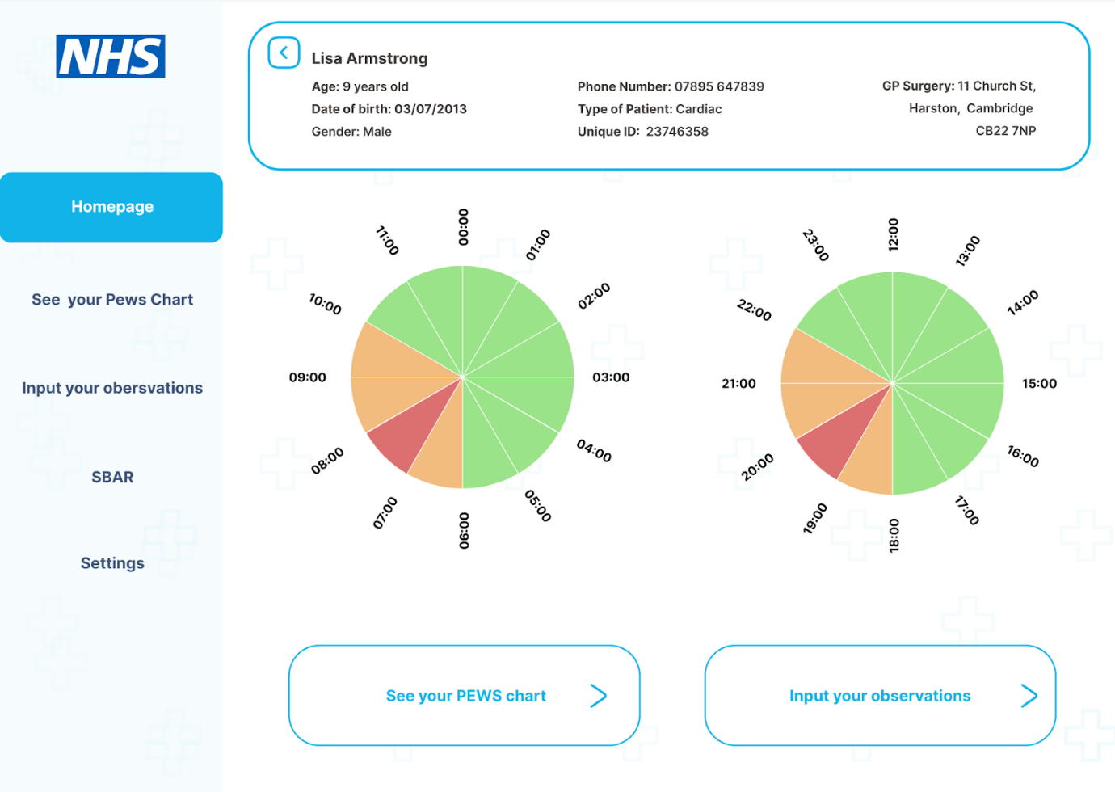
Figure 10: Redesigned homepage dashboard
Prior to the redesign, features such as the calendar (which users testing identified as redundant) and the information boxes and the bottom of the page (showing unnecessary information) were eliminated, reducing the number of elements on the main page from 8 to 6.
In other EHRs such as SystmOne and Epic, already used by the CCNs, patients key information such as name ,date of birth age and contact details are displayed at the top of the page, meaning that health professionals have immediate access to this information. In response to this a further improvement in the redesign was moving patients information to the top of each page, thus complying with Jakobs design law (Nielsen, 2000) indicating that users prefer sites similar to ones they already use.
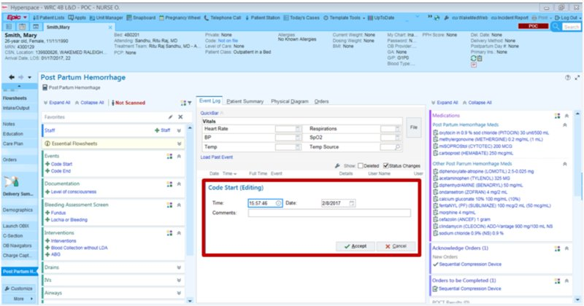
©EHR in Practice
Figure 11: Epic EHR software with fake patient information displayed at the top of the page - Epic (2017)
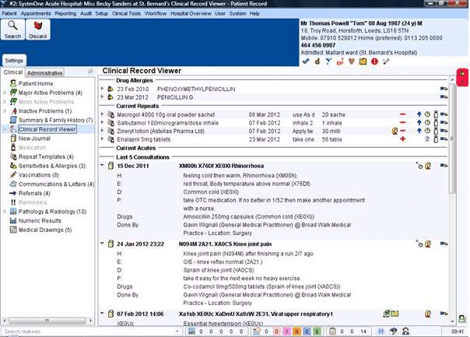
©tpp.uk
Figure 12: SystmOne EHR software with fake patient information shown at the top of the page - Chapman, N (2017)

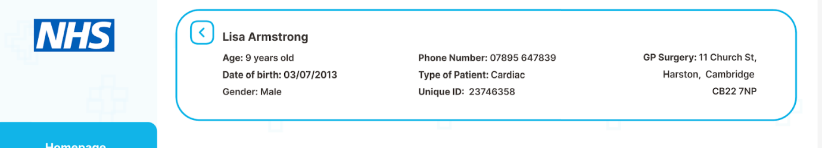
Figure 13: Patient information displayed at the top of the prototype page

The “washed out” colours were also addressed in the redesign. Although they were originally done to try and give a calm response the community nurses expressed that they wanted it to be brighter so they could see the colours better. This was also carried over onto the PEWS charts. This allows CCNs to instantly see if the values are outside of “normal” parameters and identify patterns in the data.
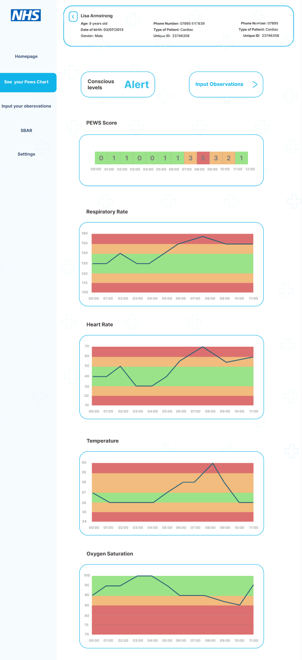
Figure 14: Redesigned PEWS chart page
Following suggestions from the interviews a search bar was added allowing the nurses to search for the patients they want to look at. This helps with the overall user experience as the CCNs can quickly find the patient they are looking for instead of going through the list of patients. A Note section was also added so that comments regarding a child's visual presentation could be added to the notes along with the observations recorded.

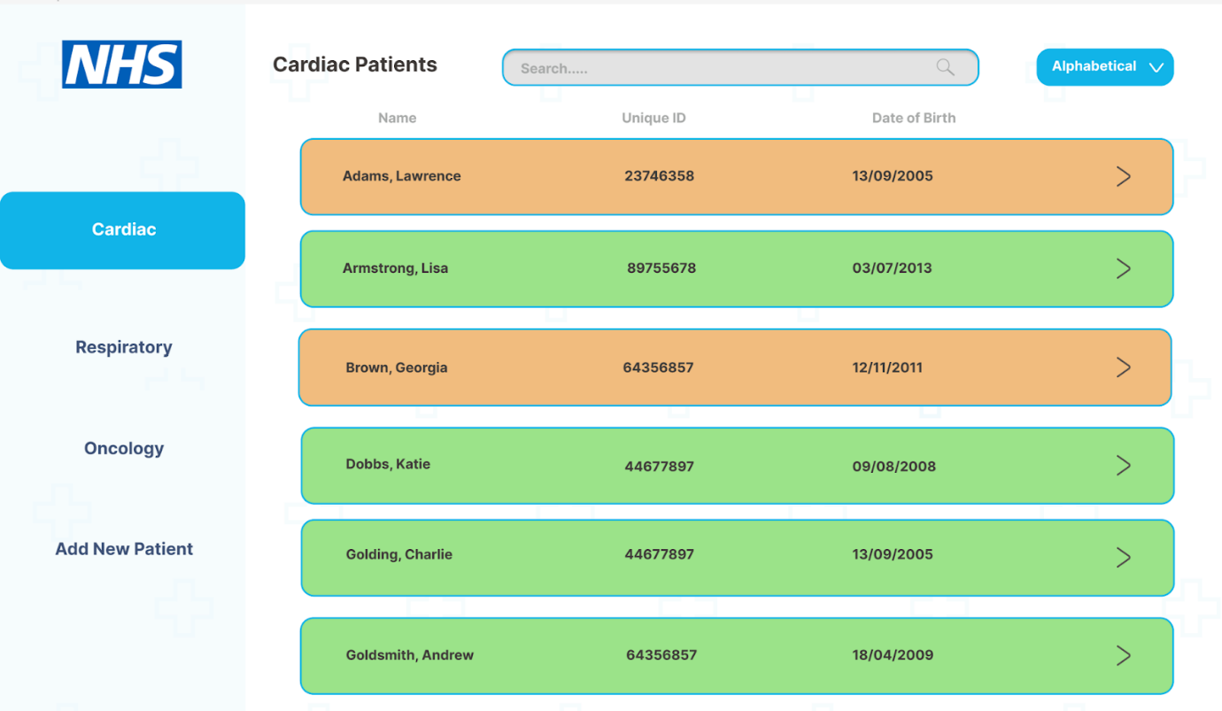
Figure 15: Redesigned patient case load page
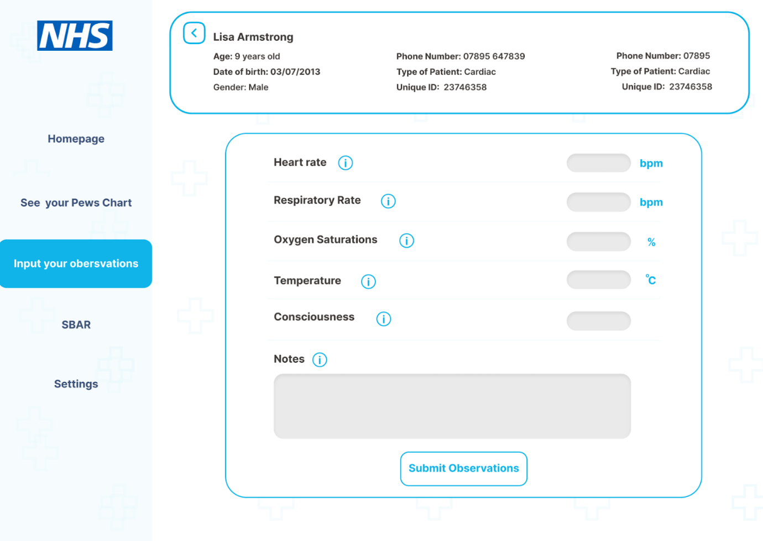
Figure 16: Redesigned input observation page
A new information page was also added to the navigation bar. This page displays the SBAR (situation, background, assessment, recommendation) which is a structured communication tool used in the NHS to accurately share information between individuals. In the interviews it was expressed this would be helpful to clarify what information needed to be shared as well as supporting new CCNs who may not be used to escalating concerns from the community.
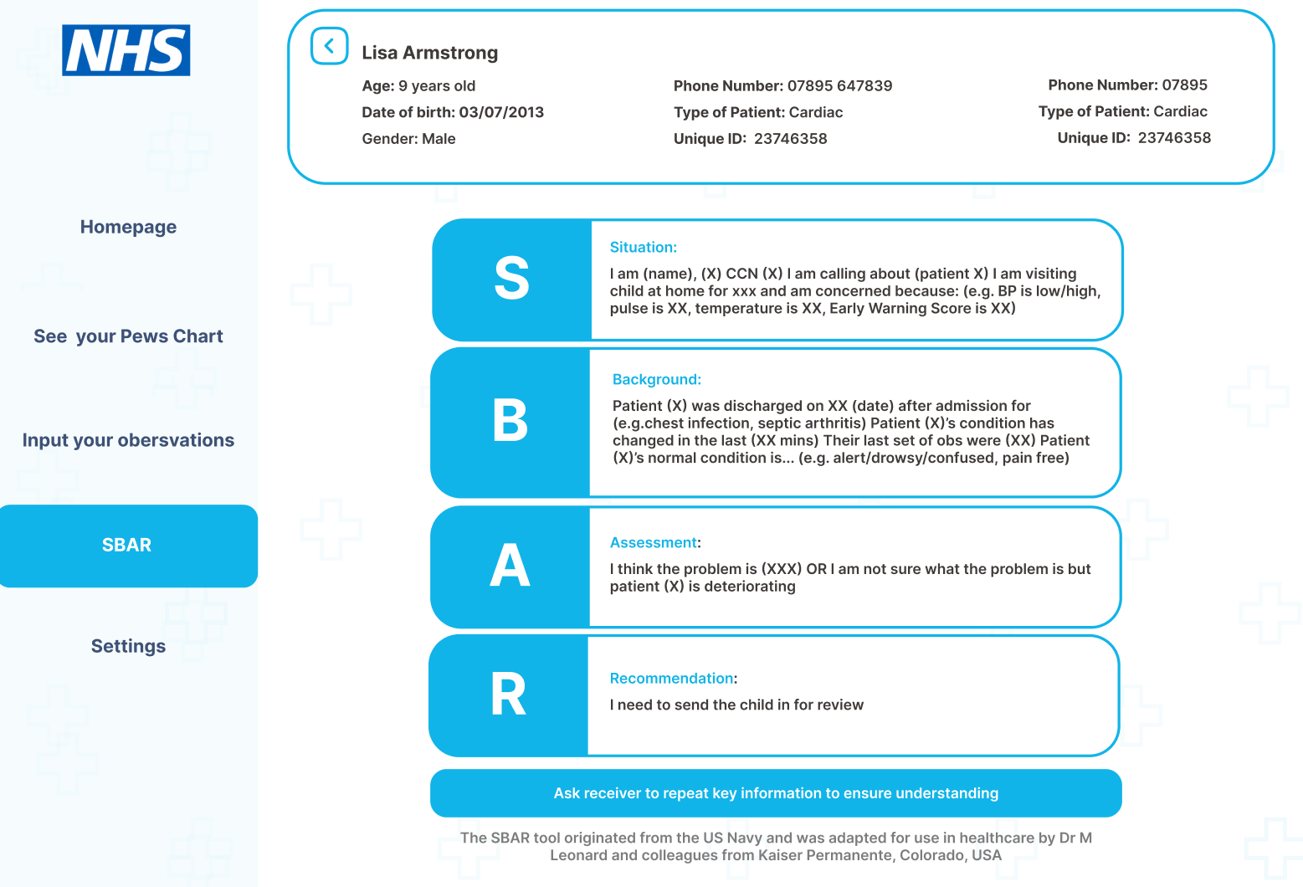
Figure 17: SBAR page design

4.6 Implementation

4.6.1 Introduction
Originally the electronic PEWS web application was going to be coded in Laravel however, as Laravel had not been used before this meant a lot of time was spent attempting to learn the new coding framework, limiting the number of features that could be implemented. As we also encountered delays to the user testing due to NHS strikes the decision was made to change to PHP a framework that had been used before on another project, this was a good decision as coding was much quicker.
Along with PHP, MySQL was used as a relational database, as it is very compatible with PHP and also has a variety of built in security features. As the app will be using personal information, this was very important. MySQL also allows for a large amount of scalability and traffic which would be helpful in further development as the NHS has an extremely large amount of data which needs to be accessed at the same time by multiple individuals.
Before coding commenced XAMPP was installed which was helpful as it contains all the necessary components for making a web application in PHP such as Apache, MySQL, and PHP itself. It also provides a development and testing environment, allowing the web application to be tested and developed locally without a live server.
To help with risk management the code was stored on GitHub which allowed version control and a backup of the code. (To view link to code see appendix A)
Features of the application were prioritised into sprint systems in order of importance. This was helpful as the allotted time for implementation got cut down significantly due to nurses being busy and nurse industrial action.

Priority | Overarching features | Specific features | Completed
1 | Caseload patient page | - Displaying patients on specific pages according to their illness  - Filter system  - Search bar | Completed
2 | Main dashboard page | - Displaying patient information overview at the top of the page  - PEWS score pie chart  - Navigation Buttons in the main dashboard | Completed
3 | Navbar navigation | - Showing the active page on the nav bar by highlighting it in blue | Completed
4 | Inputting observations page: | - Observation form  - Inputting information to the database | Completed
5 | Add new patient page | - Add a new patient Form  - Inputting information to the database | Completed
6 | PEWS charts page | - PEWS charts linking to database | Partly implemented
7 | Sbar page | - Basic information and styling | Completed
8 | Login page | - Authentication  - Connecting to a database | Not implemented
9 | Sign up new patient: | - Authentication  - Connecting to a database | Not implemented
10 | Settings: | - Changing details in database | Not implemented
11 | Home page | - Basic information and styling | Not implemented
Table 10: Table showing the priority of the features in the web application

4.6.2 Database
An entity relationship diagram (ERD) was created to help map out how our MySQL database was going to link together and what tables we would overall end up needing for this project.

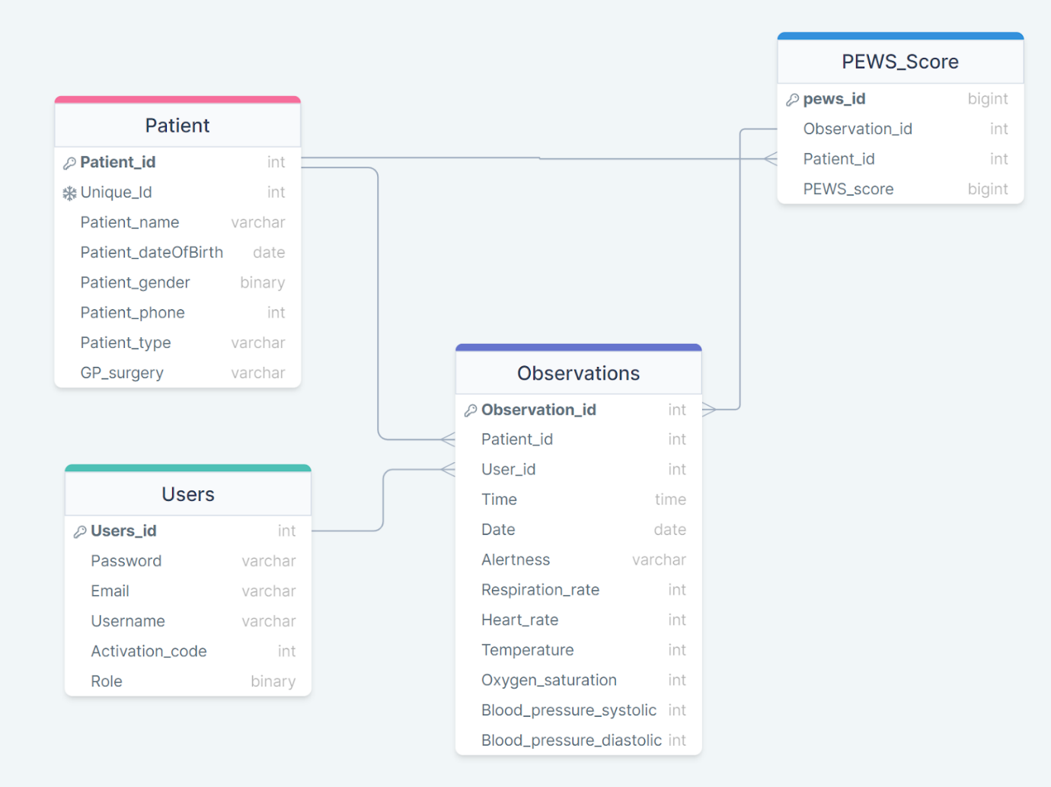
Figure 18: ERD diagram of the database
The ERD shows the different relationships between the 4 different tables in the database and how they are connected. The Observations table has 2 foreign keys in it connecting it to other tables, Users and Patient. Both tables are linked to the observations table by a one to many connection meaning that many observations can be taken for one patient and that one CCN can take many observations. Having this information in the observation table of the database means that the observations taken are identifiable to a specific patient, therefore if a patients observations were recorded in the wrong patients notes it would be possible to established which CCN had recorded them, making any investigation easier. The PEWS score table also has foreign keys allowing the observations and patient table to be linked to it.

4.6.3 Functions
Across each webpage various functions are used and these are laid out in the Function folder. These functions are related to user authentication, user management, patient data retrieval, and PEWS score calculations.
Although all functions were attempted and written out not all of them were implemented and working. These functions include is_authorized, loginUser, signupUser.

- is_authorized($required_role): Checks if a user is authorised to access the web application based on their “role” (whether they are a nurse or not). It checks if the user is logged in by verifying the presence of the user_id in the session. Then it compares the user's role (user_role) with the required role. If the user's role is less than or equal to the required role, it returns true; otherwise, it returns false. This allows users to see certain pages based on their role for example a parent/guardian would only be able to see their specific childs PEWS page whereas CCN nurses would be directed to view the caseload patients page allowing them access to all the patients on their caseload.

- loginUser($username, $password): Validates users credentials and logs the user into the application. It takes in the username and password as parameters and checks if a user with the given credentials exists in the database. It executes a SQL query to select the user from the users table based on the provided username and password. If a user is found in the database, the function returns the user data as an associative array; otherwise, it returns false.

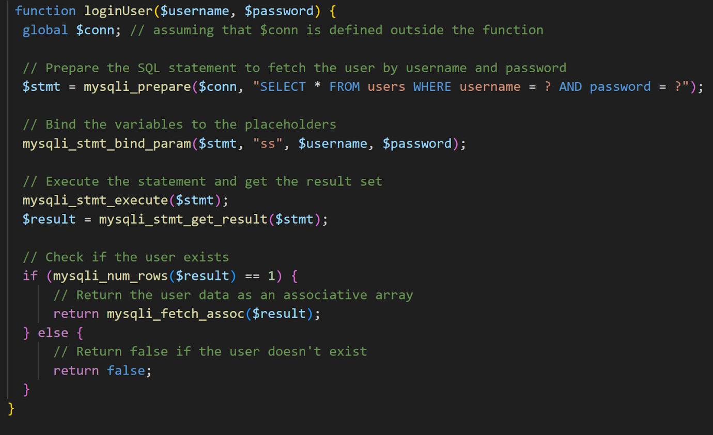
Figure 19: Code for LoginUser function
- signupUser($username, $password, $email, $dob, $phone_number): Registers users to the application. Takes in various information such as username, password, email, date of birth, and phone number as parameters. A random activation code is generated and inserted into the users table along with the other user data. It then returns the generated activation code to the user. This activation code would then be given to parents/guardians allowing them to login. This ensures that an account was actually created and set up for them by a CCN nurse.

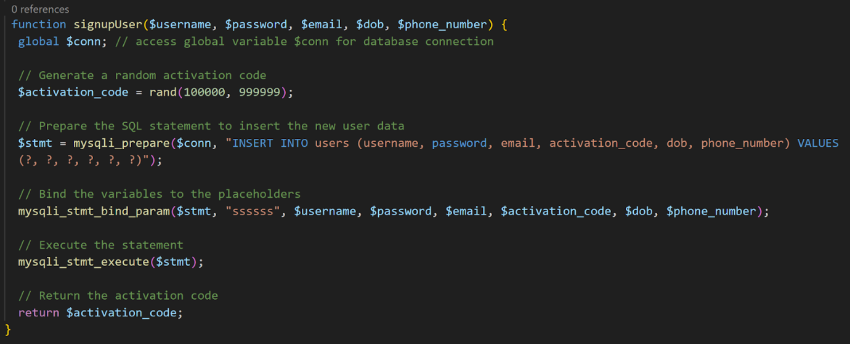
Figure 20: Code for SignupUser function

- addNewPatient($user_id, $name, $dob, $gender, $phone, $patient_type, $unique_id, $activation_code): This function adds a new patient to the database. It takes several parameters related to the patient's information, including the user ID of the associated user, name, date of birth, gender, phone number, patient type, unique ID, and activation code. It verifies the activation code's validity, updates the user table to remove the activation code, and inserts the patient data into the patients table. It returns the newly inserted patient's ID if the activation code is valid; otherwise, it returns false.
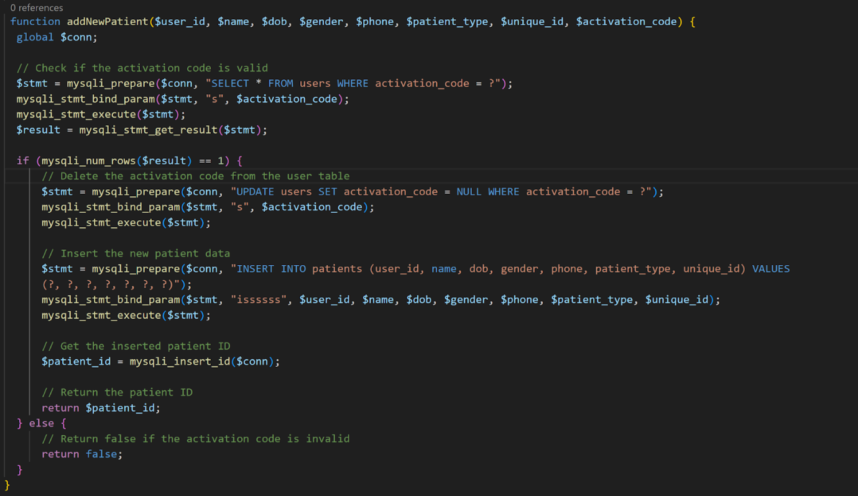
Figure 21: Code for addNewPatient function

- getAllPatientData(): retrieves patient data from the database. A SQL query joins the patients table with the Observations table to fetch the latest observation for each patient. It uses the calculatePEWS function to work out the PEWS score and assigns a colour code, using getPEWSColor, to each patient based on the score. The function returns an array of associative arrays containing the patient data
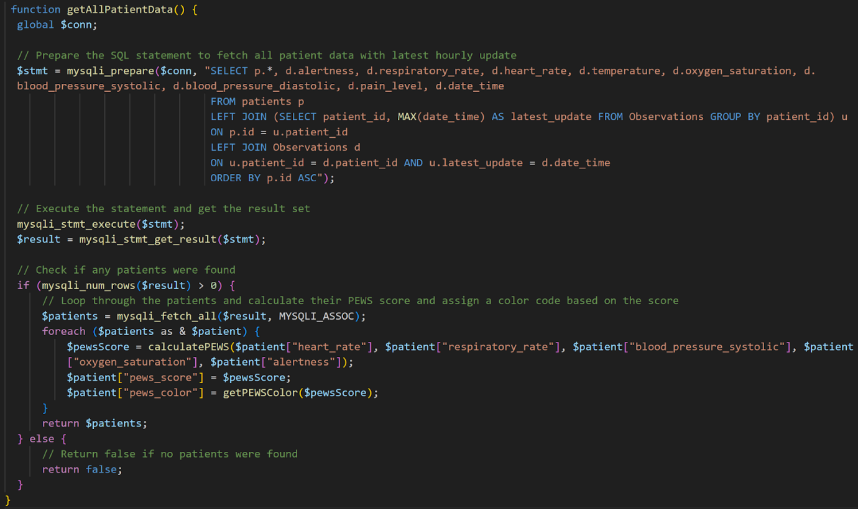
Figure 22: Code for getAllPatientData function

- getPatientDataByID($id): All the patient data for a specific patient ID is retrieved. It executes a SQL query similar to getAllPatientData(), but a WHERE clause fetches data only for the specified patient ID. The function returns an associative array containing the patient data if a patient is found with the given ID; otherwise, it returns false. This means that information regarding a specific patient can be displayed.

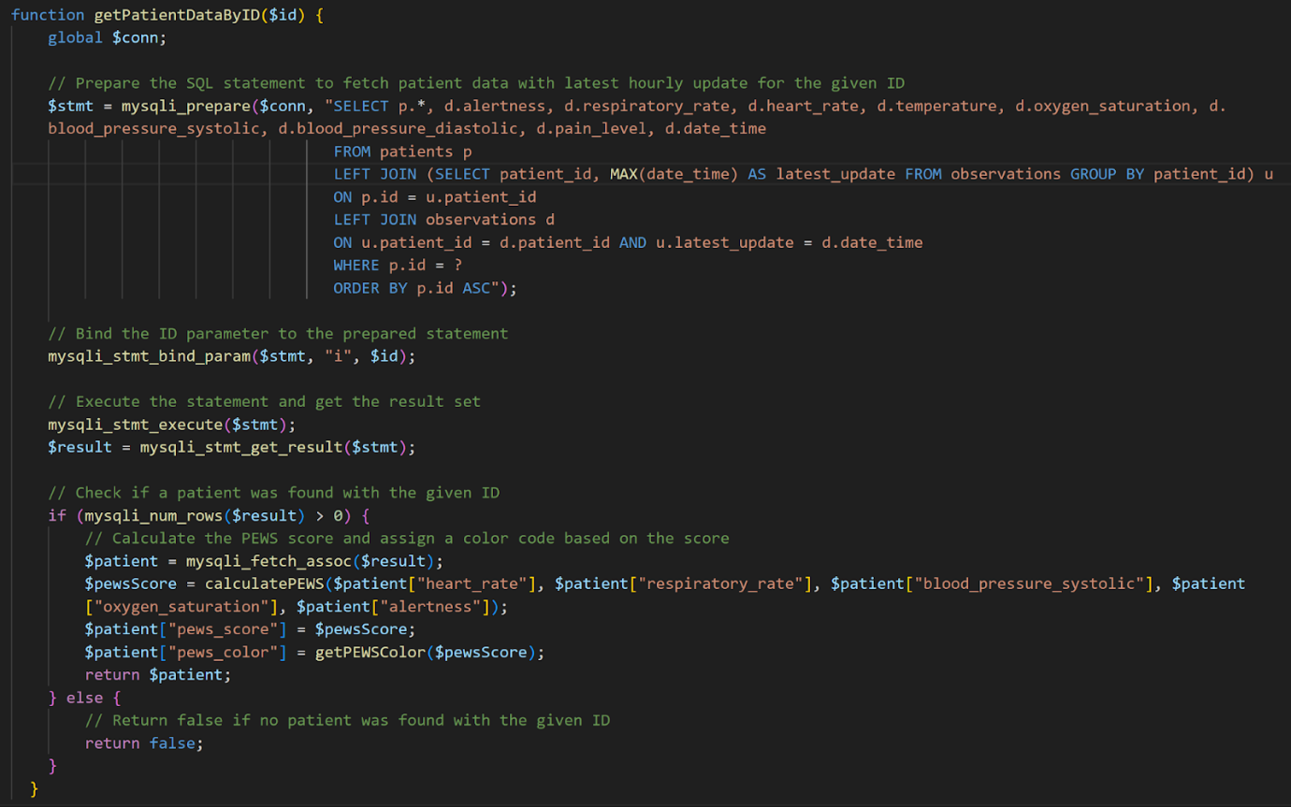
Figure 23: Code for getPatientDataByID function

- getPatientHourlyUpdates($patient_id, $time): This function retrieves the time observations were taken for a specific patient.

- calculatePEWS($heartRate, $respiratoryRate, $systolicBP, $oxygenSaturation, $consciousness): the $PEWSScore is initialised at 0 and increments based on if the criteria is met. Each observation is passed through various if statements and compared against predefined ranges to determine the score for each parameter. This then outputs a PEWS score for the patient.

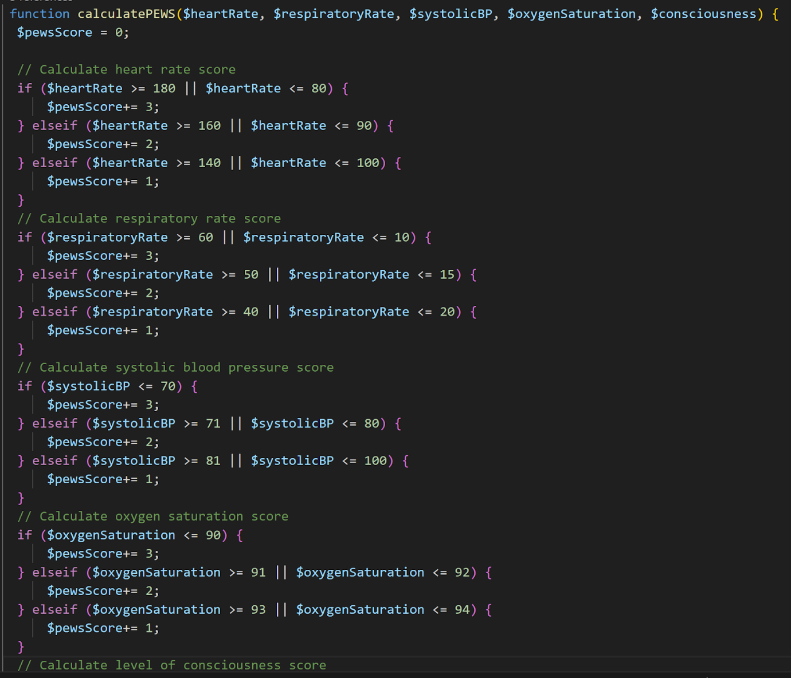
Figure 24: Code for calculatePEWS function

- getPEWSColor($PEWSScore): This function helps work out the colour represented with a given range of PEWS scores. The PEWS score is inputted into a if statement and evaluates it against predefined ranges to determine the appropriate colour. This allows healthcare professionals to easily visualise the severity level of a patient's condition, enabling prompt and appropriate clinical interventions.
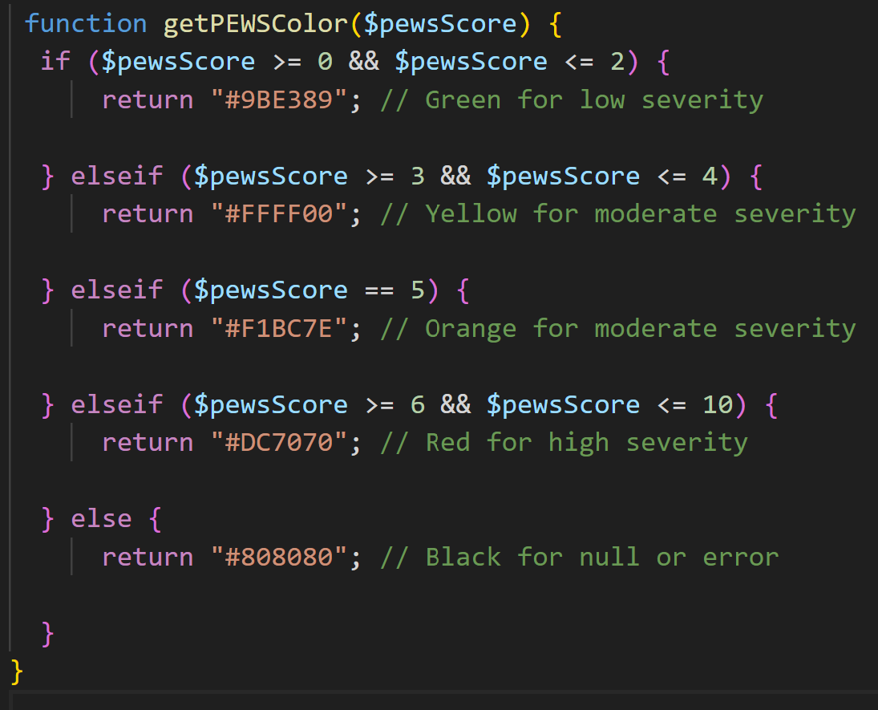
Figure 25: Code for getPEWSColor function

4.6.4 Sections of the application
- Case load patient page:
The PHP code utilises the getAllPatientData function from the functions.php file to retrieve patient data from a database. The function has two optional arguments, namely sortBy and patientType, which allow for sorting and filtering of the patient data based on parameters such as name, unique ID or date of birth. The fetched patient data is stored in the $patientData variable.
The patient data is then sorted based on the chosen option, using a switch statement and the usort function. The sorted data is stored in the same $patientData variable.
The patient data is subsequently displayed in an HTML table, with the option of filtering by patient type through links at the top of the page. Additionally, a dropdown menu at the top of the page enables sorting by name, unique ID, date of birth, or patient type. Each row of the table displays the patient's name, unique ID, date of birth, and an arrow icon that links to the patient's details page.
Furthermore, the code includes links to add a new patient and view settings.
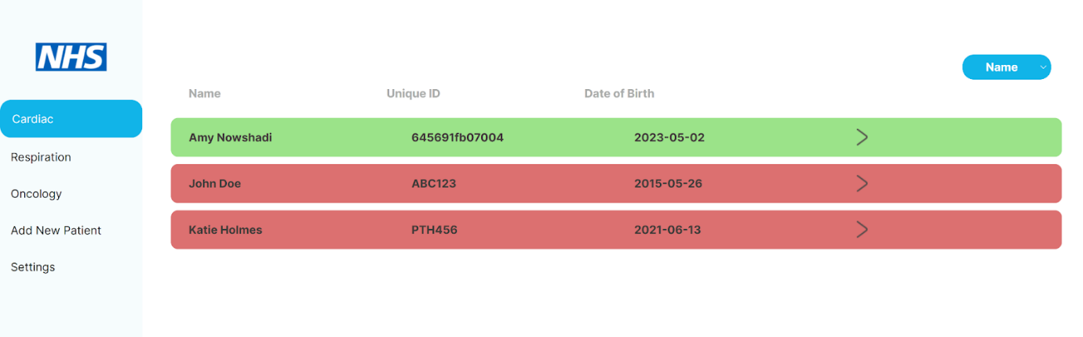
Figure 26: Implemented patient caseload page

- Main dashboard page:
The PHP code begins by including a functions.php file that contains functions for interacting with the database. It then retrieves the id parameter from the URL using the $_GET superglobal variable and passes it to the getPatientDataByID function to retrieve the patient data. The patient data is then displayed on the webpage using HTML and PHP.
The code also retrieves hourly updates for the patient using the getPatientHourlyUpdates function and stores them in the $observation variable. However, this variable is not used in the code.
The code also generates two pie charts using the Google Charts API. The charts display the number of hours spent in each time interval (e.g., 00:00-01:00, 01:00-02:00, etc.) over a two-day period. The charts are generated using the google.visualization.PieChart function and are displayed in two separate div elements on the webpage. Due to time constraints the graphs could not be implemented properly to display data from the database so the colours represented on the graph are hard coded in. If the implementation section has more time ajax and JSON would have been used to get display the actual values from the database.
The code also includes links to other pages on the website, such as the PEWS chart page and the observations page.
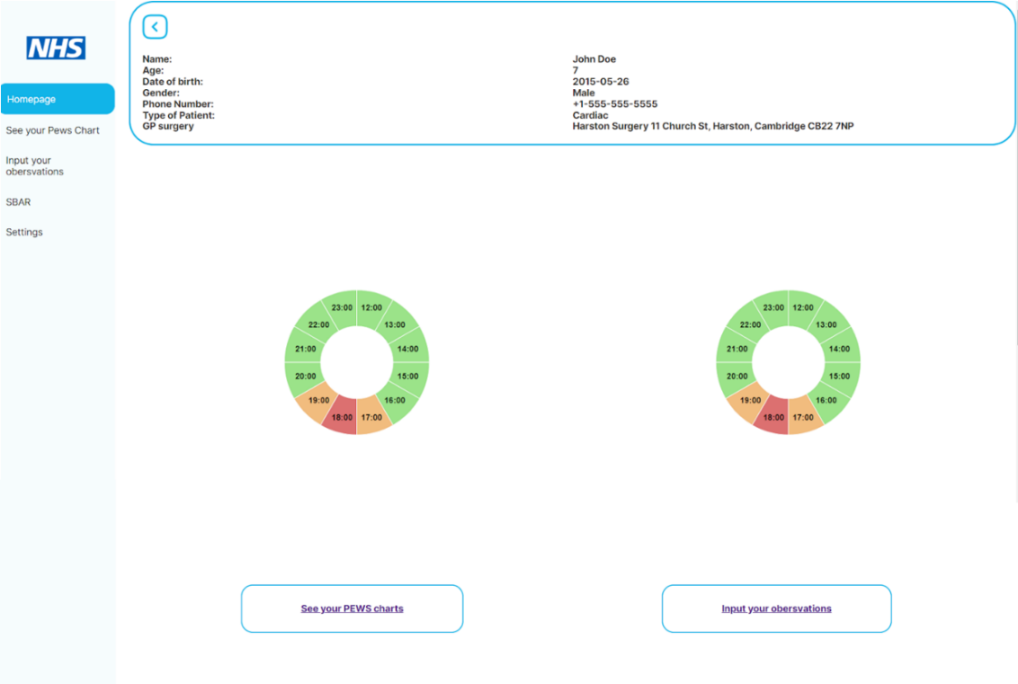
Figure 27: Implemented homepage dashboard

- Input observations page:
The PHP code defines a form to input patient observations and inserts the data into a database. It also retrieves patient data from the database and displays it on the top of the page.
The code then checks if the form has been submitted using the $_SERVER['REQUEST_METHOD'] and isset() functions. If the form has been submitted, the code sanitises and validates the input data using the filter_input function and the FILTER_SANITIZE_FULL_SPECIAL_CHARS filter. If the input data is valid, the code inserts the data into the database using a prepared statement and the bind_param and execute methods. If the insertion is successful, the code redirects to the same page with a success message.
The code also defines a form to input patient observations. The form uses the POST method and submits to the same page. The form fields are validated using the required attribute, and the input data is sanitised and validated using the filter_input function. The patient name is called from the database and pre-inputted into the form so that the CCNs can ensure they are inputting the observations into the right patient records, reducing errors and GDPR issues. In order to enhance risk management, additional error handling was implemented in the application. For instance, when an extreme value is entered, a prompt is displayed to confirm the accuracy of the entered value. Along with this if a value that could not be possible is imputed eg an oxygen saturation which was greater than 100% the form would not send and the user would be notified to check this.
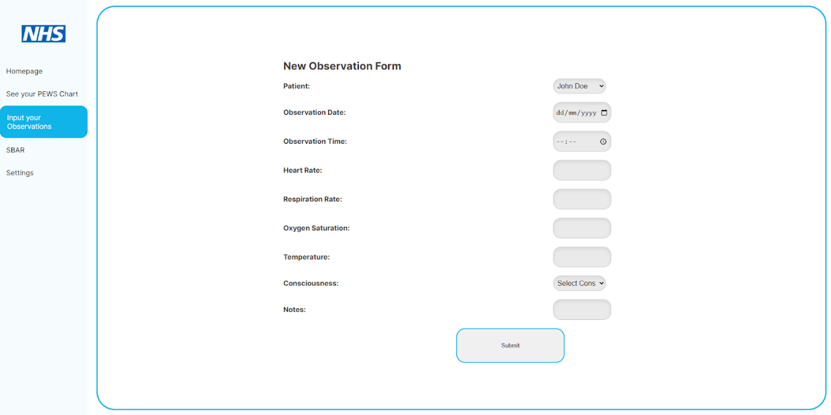
Figure 28: Implemeted input observation page

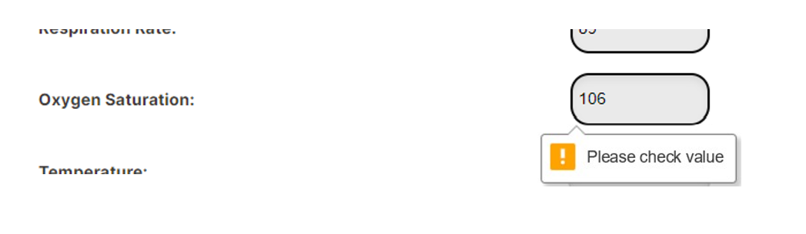
Figure 29: Example of error handling in the observation form when an extreme value is inputted

- Add new patient page:
The HTML code contains the form that allows users to enter the patient's name, date of birth, gender, phone number, and patient type. The form uses the POST method to submit the data to the PHP code.
The PHP code allows users to add a new patient to a database. It then checks if the form was submitted using the same methods as the input observation page. The code then generates a unique ID for the patient using the uniqid() function. If the input data is valid, the code inserts the data into the database using a prepared statement to prevent SQL injection attacks. This helps with security which is extremely important when dealing with personal information such as addresses and date of births.
The code then closes the database connection and redirects to the same page with a success message if the insertion is successful. If the form was not submitted or there was an error, the code displays the form again with the appropriate error message.
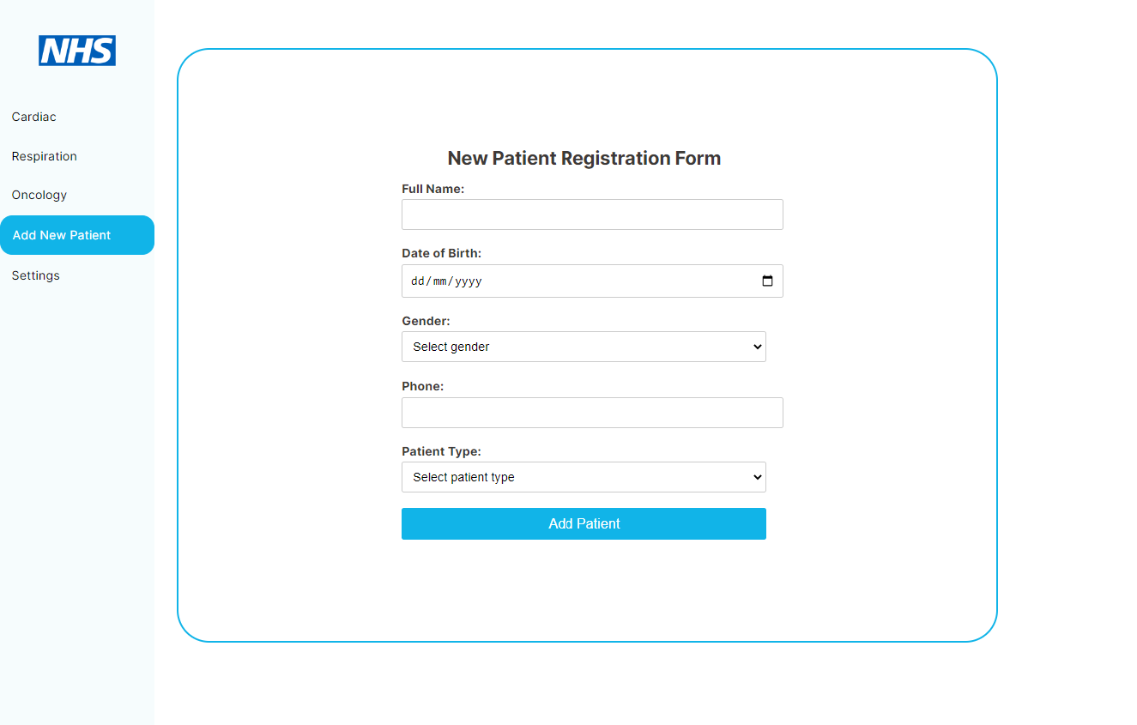
Figure 30: Implemented patient registration form

- PEWS chart page
The retrieved patient data using the function getPatientDataByID it is then displayed on the top web page using HTML and PHP
The code also generates charts using the Chart.js library to display patient data. The charts display the patient's PEWS score, respiration rate, heart rate, temperature and oxygen saturation. The time for the last 24 hours are displayed at the bottom of the chart while the units of measurement are displayed on the left hand side. The data for the charts is currently hard coded but if more time was available this data would be retrieved using the getPatientHourlyUpdates function. The chart data is then displayed on the web page using HTML and JavaScript.
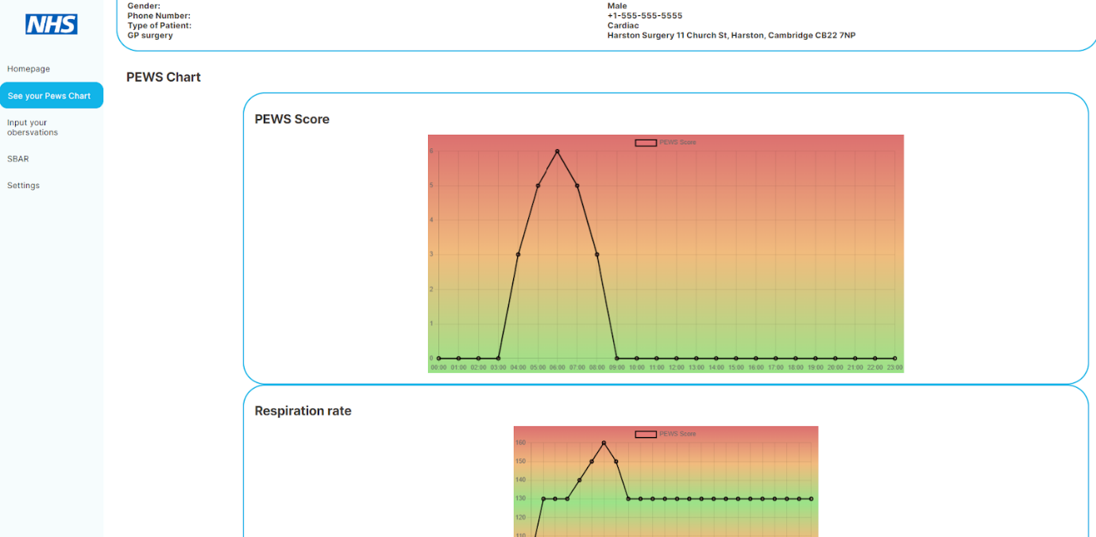
Figure 31:Implemented PEWS chart page - Top
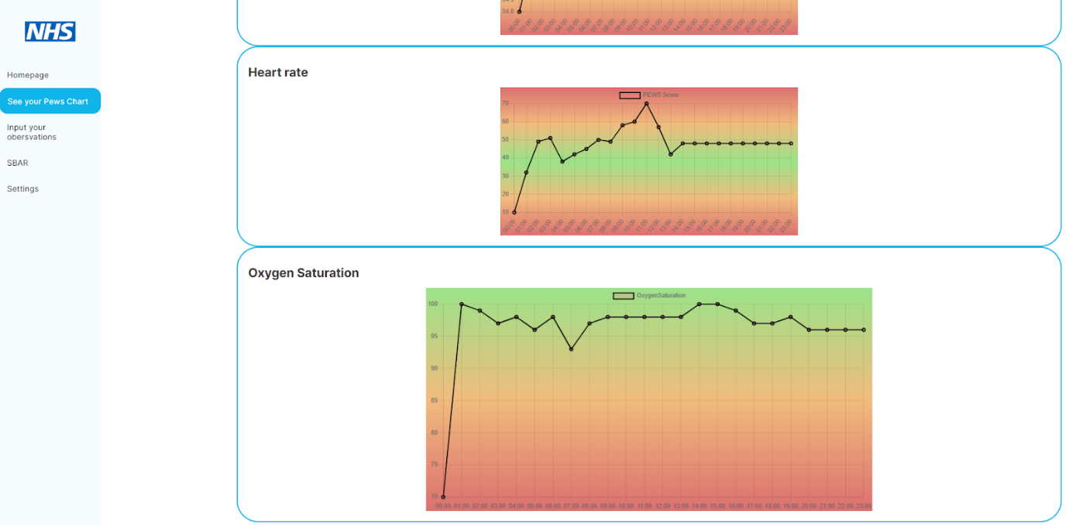
Figure 32: Implemented PEWS chart page - Bottom

4.7 Professional, Legal and Ethical issues
Prior to starting, Solent University’s ethical clearance form (see form in appendix E) had been submitted outlining that data collected would be used ethically and in line with the Solent University Ethics Policy. The Service Lead for the CCN team, also contacted the Research Lead for the trust and I met with her for discussion around the aims of the project and exactly what input was required from the Trust. The discussion centred around the possible use of confidential information and GDPR, once it was understood that there was no patient data or service sensitive information required, rather just views of CCNs on PEWS then permission was granted to contact the CCNs.
To keep within these GDPR regulations and ethical guidelines the survey was only sent out to CCN nurses rather than family members such as parents and carers.
A disclaimer was included at the start of the survey stating that no identifiable information would be collected and that by completing the survey participants are agreeing to the Solent University privacy policy. The interviewees were also asked if they consented to the interview being recorded and they were informed that they would be kept anonymous and that only the transcripts would be used.

Single Visit
 | Not in rush hour (13:00) |  |  |  | Rush hour (17:00)
Overall values | Pre-development | Post-development | Difference | Percentage decrease | Pre-development | Post-development | Difference | Percentage decrease
Time (seconds) | 2831.8 | 1513.8 | 1318 | 47% | 4572 | 2594 | 1978 | 43%
Mileage (m) | 13 | 6.5 | 6.5 | 50% | 13 | 6.5 | 6.5 | 50%
Cost (GBP) | £23.24 | £12.16 | £11.08 | 48% | £32.81 | £18.10 | £14.71 | 45%
Table 11: Results for a single visit for both not rush hour and rush hour

5. Results
To see a breakdown of these averages please refer to appendix F

Multiple Visit
 | Not in rush hour (13:00) |  |  |  | Rush hour (17:00)
Overall values | Pre-development | Post-development | Difference | Percentage difference | Pre-development | Post-development | Difference | Percentage difference
Time (seconds) | 7619 | 5769 | 1850 | 24% | 9779 | 7689 | 2090 | 21%
Mileage (m) | 45.8 | 30.4 | 15.4 | 34% | 45.8 | 30.4 | 15.4 | 34%
Cost (GBP) | £68.93 | £49.67 | £19.26 | 28% | £80.81 | £60.23 | £20.58 | 25%
Table 12: Results for multiple visits for both not rush hour and rush hour

6. Discussion
The two tables measure the time, mileage and cost that it takes to do a single visit (in rush hour, 17:00, and not in rush hour, 13:00) and to do multiple visits (in rush hour, 17:00, and not in rush hour, 13:00). For each section there are pre-development and post development results. The purpose was to determine if an electronic PEWS application made a difference across these variables. For both single visits and multiple visits the post development phase resulted in a greater percentage improvement in time and cost saving in rush hour compared to non-rush hour. However, the percentage improvement in mileage was the same for both. For multiple visits, the percentage reduction in the different variables were all lower but still significant. Both Time and cost almost halved comparing multiple visits (Time: 21-24%, Cost: 25-28%) to single visits (Time: 43-47%, Cost: 45-48%). The results show a significant improvement across all scenarios in post development, indicating that the PEWS tool would save time and money for the NHS trust.
It should be noted though that these results are based on averages and do not take into account various confounding variables such as, children being apprehensive to have their observations done, therefore the visit taking longer; road works, parking and even staff shortages, which would result in nurses having to travel across county rather than doing localised visits.
Overall, the results indicate that electronic PEWS application was effective in reducing time, mileage, and cost in both single and multiple visit scenarios, and regardless of the time of day. It is worth noting that while percentage improvements are significant, the actual difference in values between pre and post-development phases may be relatively small, especially for mileage.

7. Conclusions
The purpose of this project was to design a Digital PEWS tool that could be used by the CCNs to identify children with deteriorating health in the community. After looking through the literature 3 key areas of focus were identified, “Why PEWS”, “Digitalisation in the NHS”, and “Previous attempts to digitalise PEWS”. PEWS tools are an important adjunct to the care of the CCN, early identification of a deteriorating child can enable prompt action that may result in reduced hospital admissions and serious illness. There has been a lot of talk about the importance of technology in the NHS but the move towards digitalisation is slow. The limitations of paper PEWS are that they are too susceptible to human error in either entering information or calculating the PEWS score.
The predesign surveys enabled an understanding of how CCNs use PEWS at present and highlighted some of the issues they have with the current system. It was essential to gain user input to ensure that the tool would look appealing and work in a way that the users were familiar with in order to get good engagement. Changes in post design were made in response to user feedback as well as design principles resulting in a tool that CCNs felt happy and confident with. The implementation of a Digital PEWS tool was hope to address some key areas such as, reducing admin time for CCNs, Reducing cost of nursing time and mileage
and also reducing error and risks in recording patient data.
A Digital PEWS tool was to target specific areas including, reducing admin time for CCNs, reducing cost of nursing time and mileage and also reducing error and risks in recording patient data. The reduction in time and money was clearly evidenced in the project by the results, whilst the issue of error and risk management was difficult to ascertain. This would have required access to the CCNs as they spent time with patients, record observations and then travelled back to base to input them, issues around GDPR and ethics especially in dealing with children made this impossible although reviewed literature certainly supports that reduced risk would be an outcome.
Overall, the digital PEWS tool was a success, users report a willingness to use it and find it easy to access. Implementation of this application results in savings in time and money for a severely overstretched NHS as well as giving clinicians a clear insight into patterns in children’s observations over a period of time. Recommendations for further implementation would result in a tool that could be not only viewed historically but also used to predict future health requirements.

8. Recommendations

8.1 Finish implementation of all features
Due unforeseen issues which arrived during the development, full implementation of all the features could not occur. This would be the first step taken if future development was to occur with this project.

8.2 Extra security
More security measures should also be added to the application such:
- Error handling and logging: Implementing this would allow any errors or exceptions that may occur in the database to be captured and logged preventing important information to be displayed to the user as an error.
- Parameterized Queries/Prepared Statements: To prevent SQL injection attacks.
- Escaping and Encoding: Properly escape and encode data when displaying it on web pages to prevent cross-site scripting (XSS) attacks.
- Authentication and Authorisation: Implement user authentication and authorisation mechanisms to ensure that only authorised users can access and manipulate the data in the database. Along with this two step authentication would be looked into for future development.
- Hashing: important data such as passwords and patient information should be put through hashing algorithms to prevent unauthorised access and ensure data integrity and security.

8.3 Device compatibility
Due to an oversight during the development, the app is made to run only on a 10” device, so proper organisation of the page elements so that they properly adapt to different screen sizes is required for future development of the app.

8.4 Making the PEWS parameters adjustable
Throughout the interviews and surveys many CCN’s brought light to the idea that they would ideally want to change the PEWS parameters enabling them to change the “normal” ranges of each vital observation. Implementing adjustable thresholds would enable CCNs to set warning triggers that are specific to individual children, ensuring timely and accurate detection of changes in their condition. Various healthcare services have started adapting to this idea of amending the parameters for chronic conditions. But it should be noted that a Senior clinician/specialist should be consulted before the parameters of a child are changed.

8.5 Bluetooth and wearable technology
Using Bluetooth and wearable technology to interact with the application would enable nurses to take observations without having to spend time separately recording them, as they would be automatically input from the devices. This would not only save time but also reduce the potential for transcription errors. Continuous monitoring of vital signs would allow for a more comprehensive assessment of a patient's condition. The wearable technology could include devices such as smartwatches, wireless monitoring patches, or other wearable sensors.
The integration of Bluetooth and wearable technology with ePEWS opens up possibilities for real-time analytics and allows for informed decisions to be made surrounding patients. Machine learning and artificial intelligence techniques could be implemented to identify patterns, trends, and risk indicators in a patient's observations. This analytical capability could assist healthcare professionals in making informed decisions moving forward.

8.6 Linking it to SystmOne
Linking the ePEWS tool with SystmOne would allow all the data obtained by the CCNs to be automatically uploaded to the patient's EHR. This would keep all the patient information in one place meaning that nurses would not have to navigate multiple applications. It could also result in further development as the CCNS could have access to the patient's history and other clinical information from the web application.

8.7 WIFI and hardware limitations

A factor to keep in mind is possible WiFi and hardware limitations. Although all CCNs have work phones, they do not necessarily have smartphones, thus restricting access to the internet. GDPR rules would not allow for CCNs to use their personal smartphones and so this could be a limiting factor in the establishment of the PEWS tool. Another limitation is WiFi, this is a web application and needs to be accessed via the internet, but this could be an issue if the phones don't have mobile data and even if they do this is not a secure way of transferring data.
A way to combat this would be to implement offline functionality. Data could be collected and stored locally on the mobile device then sync to the server once a stable connection is established.

9. Reference list
Agulnik, A. et al. (2017) “Improved outcomes after successful implementation of a pediatric early warning system (PEWS) in a resource-limited pediatric oncology hospital,” Cancer, 123(15), pp. 2965–2974. Available at: https://doi.org/10.1002/cncr.30664.
Asthana, S., Jones, R. and Sheaff, R. (2019) “Why does the NHS struggle to adopt eHealth innovations? A review of macro, meso and micro factors,” BMC Health Services Research, 19(1). Available at: https://doi.org/10.1186/s12913-019-4790-x.
Atasoy, H., Greenwood, B.N. and McCullough, J. (2019a) “The Digitization of Patient Care: A Review of the Effects of Electronic Health Records on Health Care Quality and Utilization,” Annual Review of Public Health, 40(1), pp. 487–500. Available at: https://doi.org/10.1146/annurev-publhealth-040218-044206.
Atasoy, H., Greenwood, B.N. and McCullough, J. (2019b) “The Digitization of Patient Care: A Review of the Effects of Electronic Health Records on Health Care Quality and Utilization,” Annual Review of Public Health, 40(1), pp. 487–500. Available at: https://doi.org/10.1146/annurev-publhealth-040218-044206.
Bartram, L., Patra, A. and Stone, M. (2017) Affective Color in Visualization. Available at: https://doi.org/10.1145/3025453.3026041.
Chapman, N (2017) SystmOne Snapshot. https://northyorkshireccg.nhs.uk/wp-content/uploads/2021/03/TPP-eRD-Screenshots-4-GM-1.pdf (Accessed: 14 April 2023).
Davies, G. (2020) Digital transformation in the NHS. Available at: https://www.nao.org.uk/wp-content/uploads/2019/05/Digital-transformation-in-the-NHS.pdf (Accessed: February 1, 2023).
Downey, L. (2007) “Group usability testing,” Journal of Usability Studies Archive [Preprint]. Available at: https://doi.org/10.5555/2835547.2835550.
Epic (2017) Epic Snapshot. Available at:https://www.ehrinpractice.com/epic-ehr-software-profile-119.html (Accessed: 14 April 2023)
Fioretti, M. (2015) “Defining staffing levels for children and young people’s services RCN standards for clinical professionals and service managers,” www.academia.edu [Preprint]. Available at: https://www.academia.edu/33912568/Defining_staffing_levels_for_children_and_young_peoples_serv.
Fruhlinger, J. (2022) WannaCry explained: A perfect ransomware storm. Available at: https://www.csoonline.com/article/3227906/wannacry-explained-a-perfect-ransomware-storm.html (Accessed: March 10, 2023).
Harper, S., Michailidou, E. and Stevens, R. (2009) “Toward a definition of visual complexity as an implicit measure of cognitive load,” ACM Transactions on Applied Perception, 6(2), pp. 1–18. Available at: https://doi.org/10.1145/1498700.1498704.
Henderson, S. (2012) “A paediatric early warning scoring system for a remote rural area,” Nursing Children and Young People, 24(6), pp. 23–26. Available at: https://doi.org/10.7748/ncyp2012.07.24.6.23.c9189.
Hennink, M. and Kaiser, B.N. (2021) “Sample sizes for saturation in qualitative research: A systematic review of empirical tests,” Social Science & Medicine, 292, p. 114523. Available at: https://doi.org/10.1016/j.socscimed.2021.114523.
Janes, A., Sillitti, A. and Succi, G. (2013) “Effective dashboard design,” Cutter IT Journal, 26(1), pp. 17–24. Available at: https://www.researchgate.net/profile/Alberto-Sillitti/publication/286996830_Effective_dashboard_design/links/57c699e208aec24de0414df1/Effective-dashboard-design.pdf.
Jordan, M. (2021) Purposive Sampling 101. Available at: https://www.alchemer.com/resources/blog/purposive-sampling-101/ (Accessed: February 1, 2023).
Kurosu, M. and Kashimura, K. (1995) Apparent usability vs. inherent usability. Available at: https://doi.org/10.1145/223355.223680.
Kutcher, E.J. and Bragger, J.D. (2004) “Selection Interviews of Overweight Job Applicants: Can Structure Reduce the Bias?1,” Journal of Applied Social Psychology, 34(10), pp. 1993–2022. Available at: https://doi.org/10.1111/j.1559-1816.2004.tb02688.x.
Liddell, A., Adshead, S. and Burgess, E. (2008) Technology in The nhS. Available at: https://www.kingsfund.org.uk/sites/default/files/Technology-in-the-NHS-Transforming-patients-experience-of-care-Liddell-Adshead-and-Burgess-Kings-Fund-October-2008_0.pdf (Accessed: March 10, 2023).
Lockwood, J. et al. (2020) “AutoPEWS: Automating Pediatric Early Warning Score Calculation Improves Accuracy Without Sacrificing Predictive Ability,” Pediatric Quality & Safety, 5(2), p. e274. Available at: https://doi.org/10.1097/pq9.0000000000000274.
Miller, G. (1956) “The magical number seven, plus or minus two: Some limits on our capacity for processing information.,” Psychological Review, 63(2), pp. 81–97. Available at: https://doi.org/10.1037/h0043158.
Mistry, P., Maguire, D. and Anandaciva, S. (2019a) Digital health care: Our position. Available at: https://www.kingsfund.org.uk/projects/positions/digital-health-care?gclid=CjwKCAjw5pShBhB_EiwAvmnN (Accessed: March 10, 2023).
Mistry, P., Maguire, D. and Anandaciva, S. (2019b) Digital health care: Our position. Available at: https://www.kingsfund.org.uk/projects/positions/digital-health-care?gclid=CjwKCAjw5pShBhB_EiwAvmnN (Accessed: March 10, 2023).
Mistry, P., Maguire, D. and Anandaciva, S. (2019c) Digital health care: Our position. Available at: https://www.kingsfund.org.uk/projects/positions/digital-health-care?gclid=CjwKCAjw5pShBhB_EiwAvmnN (Accessed: March 10, 2023).
NHS England (2014) NHS Five Year Forward View. Available at: https://www.england.nhs.uk/five-year-forward-view/ (Accessed: March 10, 2023).
NHS England (2016) Leading Change, Adding Value: A framework for nursing, midwifery and care staff. Available at: https://www.england.nhs.uk/publication/leading-change-adding-value-a-framework-for-nursing-midwifery-and-care-staff/ (Accessed: March 10, 2023).
NHS England (2019) National Early Warning Score (NEWS). Available at: https://www.england.nhs.uk/ourwork/clinical-policy/sepsis/nationalearlywarningscore/ (Accessed: March 10, 2023).
Nielsen, J. (2000) End of Web Design. Available at: https://www.nngroup.com/articles/end-of-web-design/ (Accessed: March 19, 2023).
Nikolopoulou, K. (2022) “What Is Purposive Sampling? | Definition & Examples,” Scribbr [Preprint]. Available at: https://www.scribbr.co.uk/research-methods/purposive-sampling-method/.
Palys, T. (2008) Purposive sampling. In L. M. Given (Ed.) The Sage Encyclopedia of. Qualitative Research Methods. Available at: https://www.sfu.ca/~palys/Purposive%20sampling.pdf.
Pearson, G.A. (2008) Why Children Die: A Pilot Study 2006: England (South West, North East and West Midlands), Wales and Northern Ireland [PDF]. CEMACH. Available at: https://www.publichealth.hscni.net/sites/default/files/Why%20Children%20Die%20-%20a%20pilot%20study%202006.pdf.
Roland, D. et al. (2016) “The Paediatric Observation Priority Score: A System to Aid Detection of Serious Illness and Assist in Safe Discharge,” Open Journal of Emergency Medicine, 04(02), pp. 38–44. Available at: https://doi.org/10.4236/ojem.2016.42006.
Roland, D. et al. (2021a) “Case for change: a standardised inpatient paediatric early warning system in England,” Archives of Disease in Childhood, 106(7), pp. 648–651. Available at: https://doi.org/10.1136/archdischild-2020-320466.
Roland, D. et al. (2021b) “Case for change: a standardised inpatient paediatric early warning system in England,” Archives of Disease in Childhood, 106(7), pp. 648–651. Available at: https://doi.org/10.1136/archdischild-2020-320466.
Roland, D. et al. (2021c) “Case for change: a standardised inpatient paediatric early warning system in England,” Archives of Disease in Childhood, 106(7), pp. 648–651. Available at: https://doi.org/10.1136/archdischild-2020-320466.
Royal College of Paediatrics and Child Health, Royal College of General Practitioners and Royal College of Nursing, and Royal College of Nursing (2015a) Facing the Future - together for child health. Available at: https://www.rcpch.ac.uk/resources/facing-future-together-child-health (Accessed: March 10, 2023).
Royal College of Paediatrics and Child Health, Royal College of General Practitioners and Royal College of Nursing, and Royal College of Nursing (2015b) Facing the Future - together for child health. Available at: https://www.rcpch.ac.uk/resources/facing-future-together-child-health (Accessed: March 10, 2023).
Shawahna, R. et al. (2013) “Impact of prescriber’s handwriting style and nurse’s duty duration on the prevalence of transcription errors in public hospitals,” Journal of Clinical Nursing, 22(3–4), pp. 550–558. Available at: https://doi.org/10.1111/j.1365-2702.2012.04076.x.
Snelson, E. (2019) PEWS charts. Available at: http://gppaedstips.blogspot.com/2019/11/paediatric-warning-scores-why-they-are.html (Accessed: 14 April 2023).
Sternberg, R. (2011) Cognitive Psychology. Sixth. Cengage Learning. Available at: https://www.researchgate.net/profile/Mohammad-Khakshour/publication/282182477_cognitive_psychology_edection_6/links/5606409308ae5e8e3f33705f/cognitive-psychology-edection-6.pdf.
Sweller, J. (2011) “Cognitive Load Theory,” in Elsevier eBooks, pp. 37–76. Available at: https://doi.org/10.1016/b978-0-12-387691-1.00002-8.
Tomasi, J.N. et al. (2020) “Assessing the electronic Bedside Paediatric Early Warning System: A simulation study on decision-making and usability,” International Journal of Medical Informatics, 133, p. 103969. Available at: https://doi.org/10.1016/j.ijmedinf.2019.103969.
Troncoso, X., Macknik, S. and Martinez-Conde, S. (2008) “Corner salience varies linearly with corner angle during flicker-augmented contrast,” in Art and Perception: Towards a Visual Science of Art Pt. 1, pp. 335–348. Available at: http://macknik.neuralcorrelate.com/pdf/articles/troncoso_et_al_Art_and_Perception_chapter.pdf.
Ward, J.D., Wolfe, I. and Viner, R.M. (2020) “Cause-specific child and adolescent mortality in the UK and EU15+ countries,” Archives of Disease in Childhood, 105(11), pp. 1055–1060. Available at: https://doi.org/10.1136/archdischild-2019-318097.
Whzan digital health (no date) Whzan digital health. Available at: https://www.whzan.uk/ (Accessed: January 28, 2023).
XDesign (2021) Why are sprints two weeks long? Available at: https://www.xdesign.com/blog/why-are-sprints-two-weeks-long (Accessed: February 11, 2023).

10. Appendices

Appendix A: Supporting artifact links
Link to survey:
https://app.useberry.com/t/a9WHPY8ZIrBv/
Link to prototype:
https://www.figma.com/proto/oBuY38nTunJSBnhiplty3A/PEWS-project?page-id=0%3A1&type=design&node-id=0-1&viewport=1105%2C-360%2C0.07&scaling=min-zoom&starting-point-node-id=1%3A2
Link to GitHub:
https://github.com/Amy-now/EPEWSTool.git

Appendix B: Survey questions
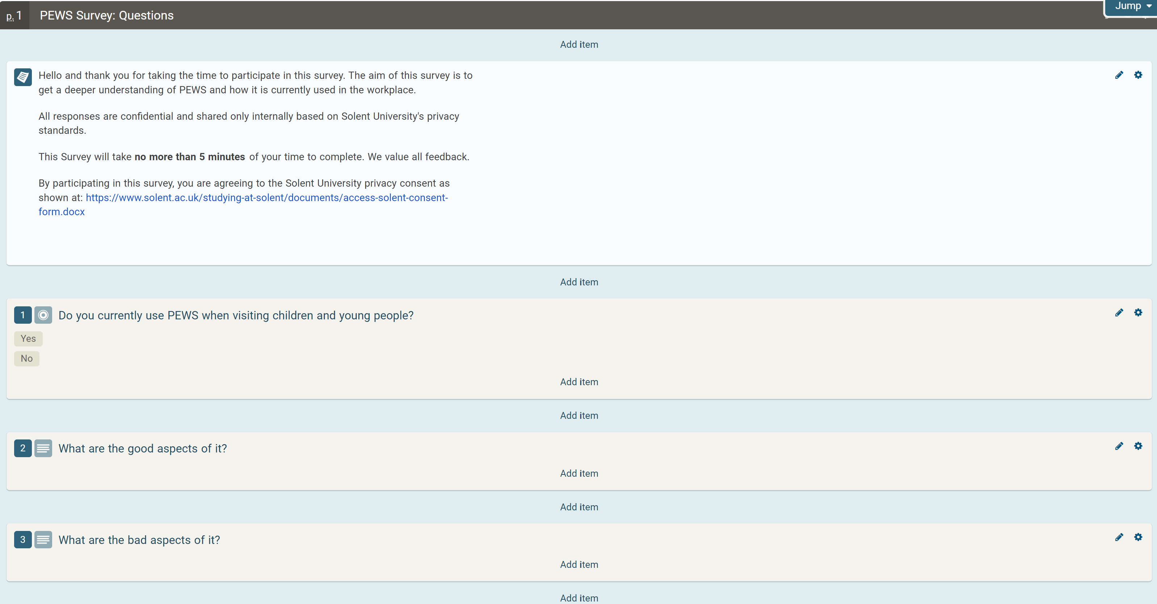
Figure 33: Survery questions part 1
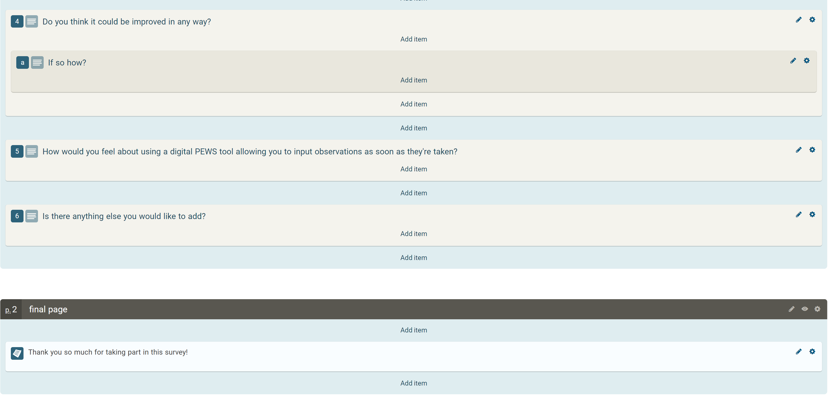
Figure 34: Survey questions part 2

Appendix C: Survey Answers
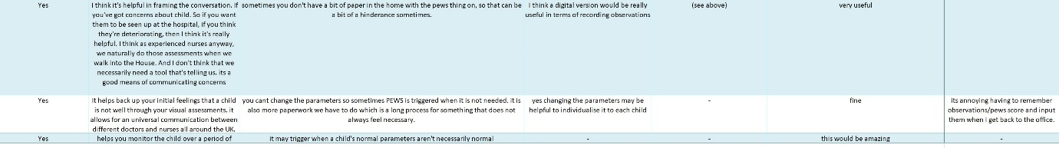
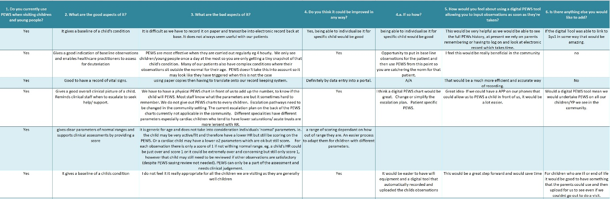
Figure 35: Survey answers
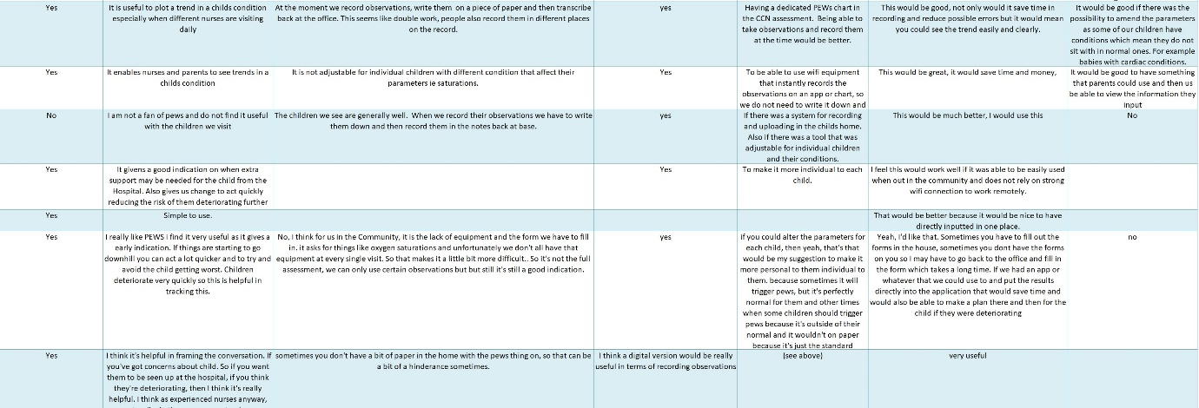

Appendix D: Wireframes
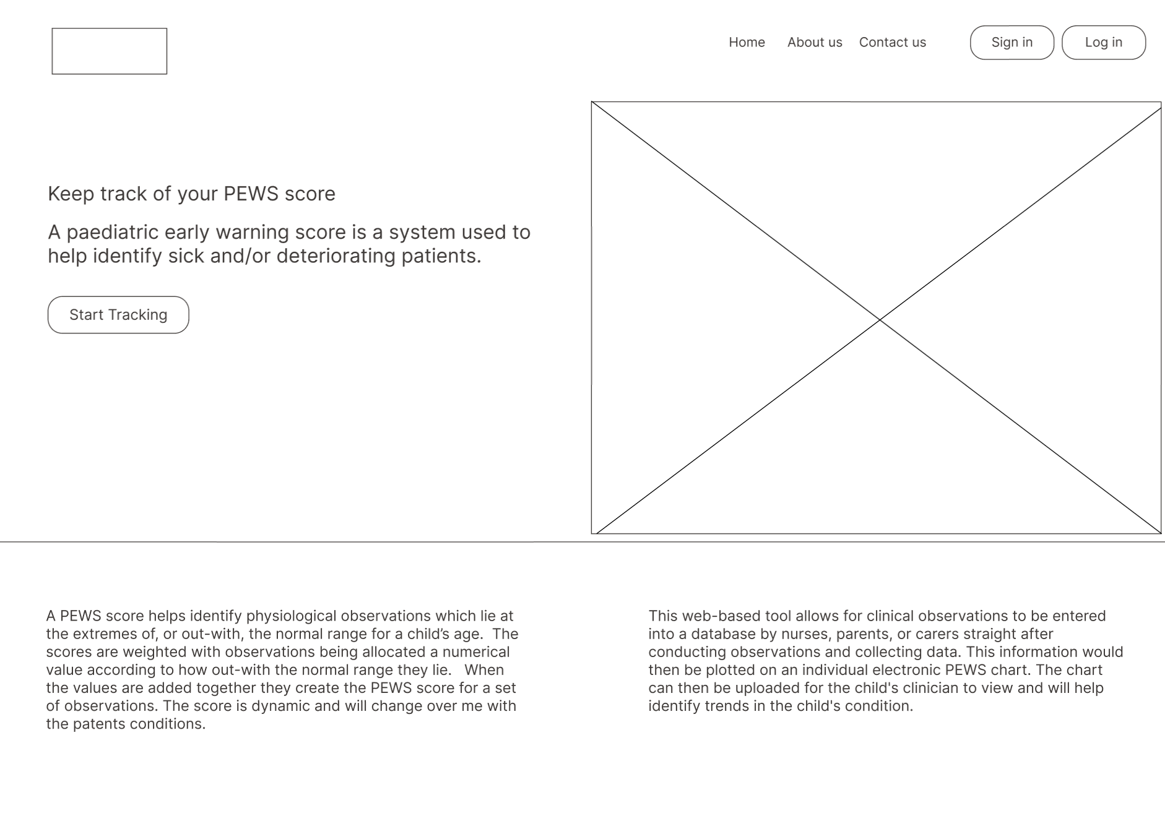
Figure 36: Wireframe for the homepage
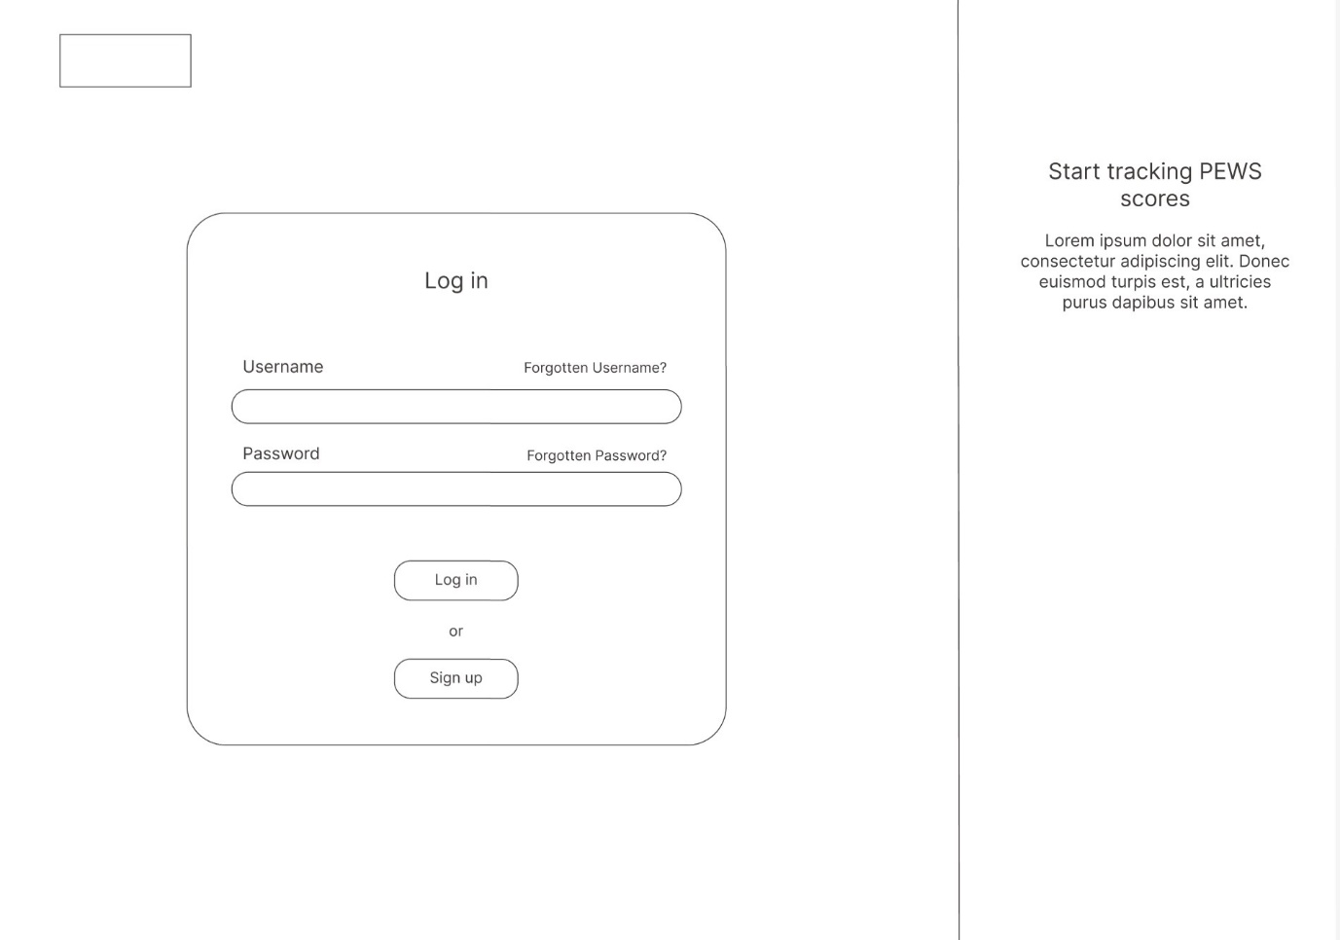
Figure 37: Wireframe for the login page
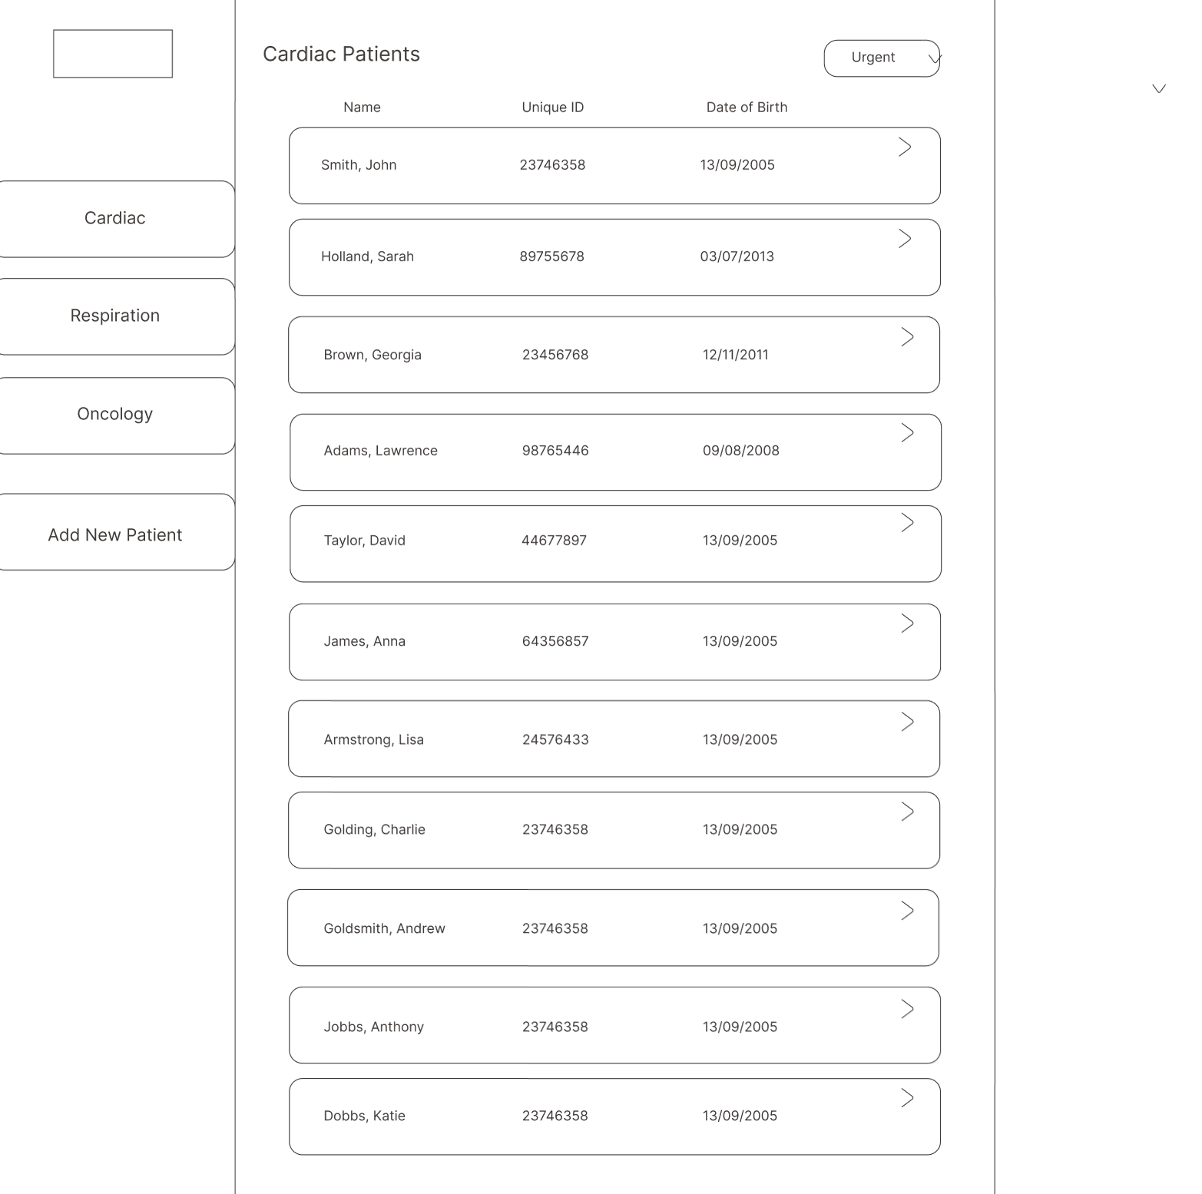
Figure 38: Wireframe for the patient caseload page

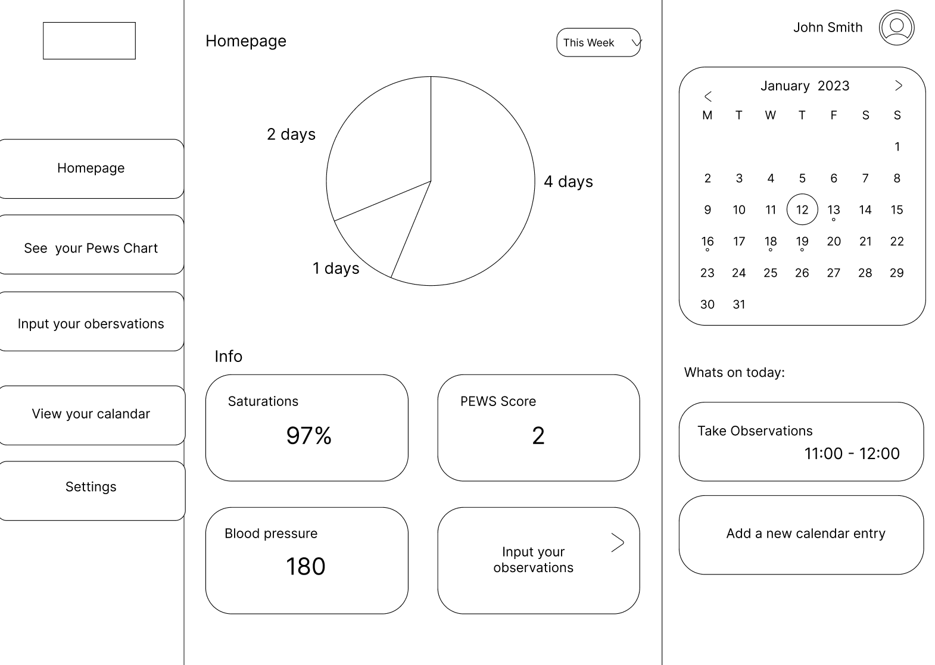
Figure 39: Wireframe for the homepage dashboard

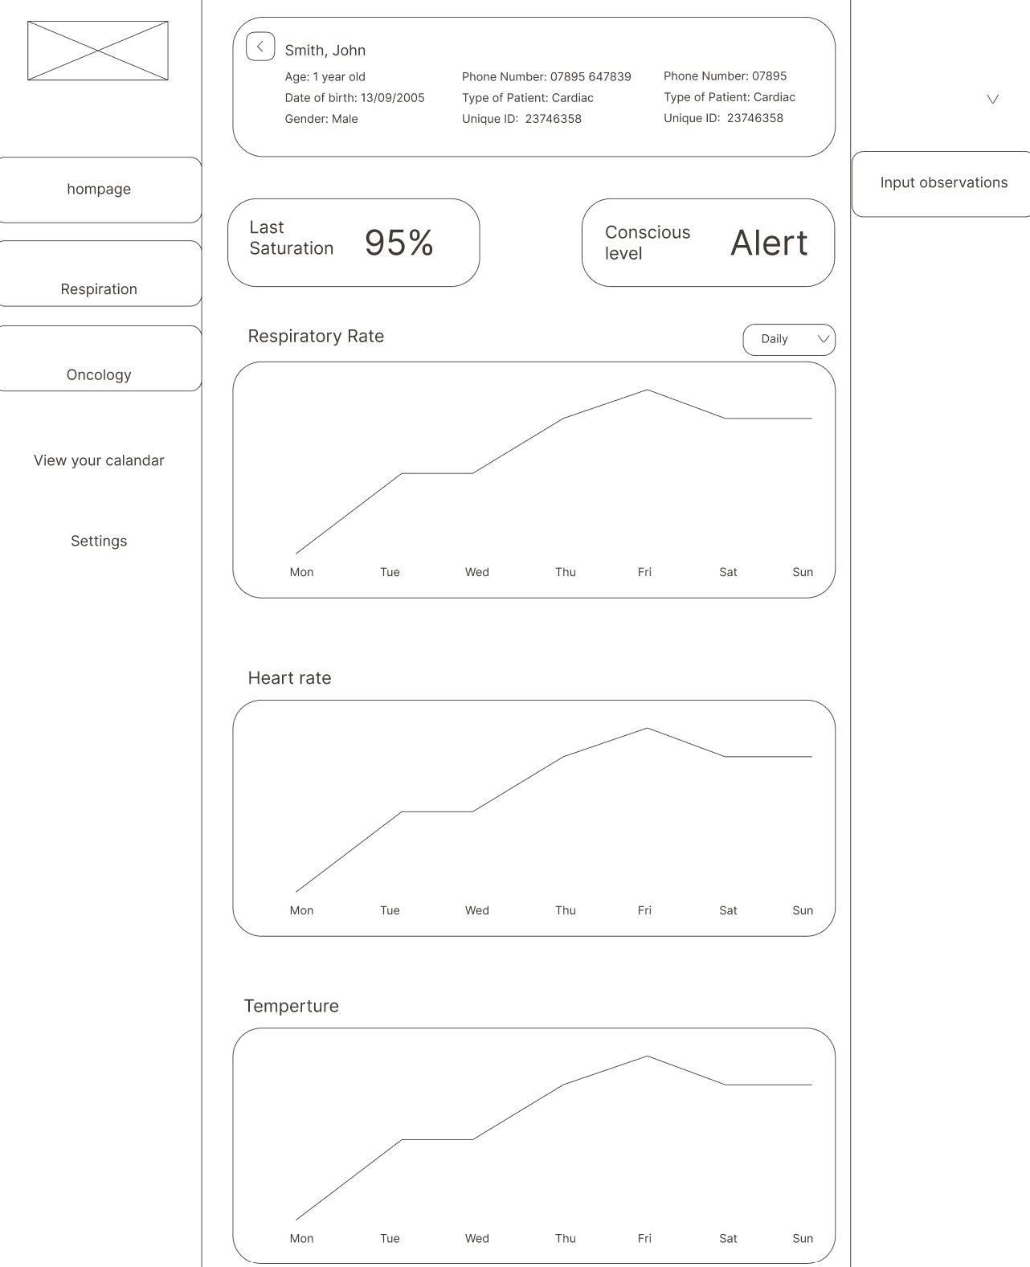
Figure 40: Wireframe for the PEWS chart page

Appendix E: Ethics form
Figure 41: Ethics form

Figure 42: Ethics form
Figure 43: Ethics form

Appendix F: Result Breakdown
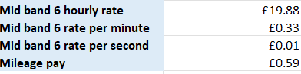
Figure 46: Nurse pay rate and Mileage pay rate
Figure 44: Time, mileage and cost breakdown for multiple nurse visits
Figure 45: Time, mileage and cost breakdown for a single nurse visit
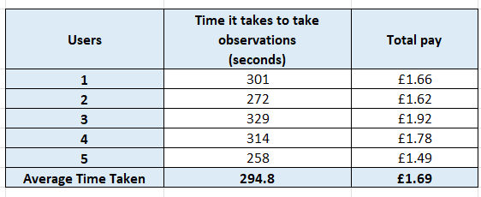

Figure 47: Table showing the time taken by each nurse to take observations
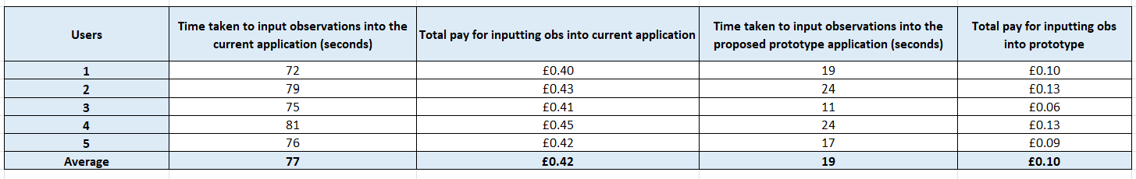
Figure 48: Table showing the time taken by each nurse to input observations into both the current EHR and the ePEWS webapplication

